

**ATLANTIC COASTAL CONFERENCE**

**HISTORICAL FOOTBALL SEASONS DATABASE**

Nick Videtti

IST-659 Section M407

Spring 2022

Summary

Let’s create a scenario where a group of student-athletes have all been offered a full-ride football scholarship to many colleges and universities. For the sake of even further simplicity, let’s assume that those colleges and universities are only those whose football program has ever been a part of the Atlantic Coastal Conference (ACC). Between location, academics, program history, and past Heisman Trophy winners, this database will allow each student-athlete to make the best decision for themselves and their future in choosing which program to join. This database will have different roles (logins and users) for Administrators, Analysts, and Queryers. It will also have a UI via Microsoft Access.

Stakeholders

**ACC:**

Once created, this database will hypothetically be updated and maintained by the Atlantic Coastal Conference. Through data analysis of this database, they will also answer some common data questions they expect may be frequently asked, as well as anything requested from schools.

**Schools:**

The schools will take data-related questions from prospective students and have the ACC provide the answers to those questions. These schools will turn to the ACC for answers to their own data-related questions, which will help those schools to advertise their programs by identifying some of the most impressive results from those data-related questions.

**Student-Athletes:**

Prospective student athletes will have the opportunity to request answers from each school to data-related questions based on this database.

Business Rules

**Schools:**

We will include all schools that have ever played a season in the ACC. This goes back to the inaugural ACC Football season in 1953.

**Seasons:**

Each season is played by one school during one year. That is, one school can not play more than one season per year.

**ACC Championships:**

During each ACC season, a champion has been crowned. Generally, and certainly in the current season format, there is one champion per year. There have been co-champions before, so we will account for that. That is, each championship is won during one year by one or more schools, and one school can not win more than one championship per year.

**Heisman Trophy Winners:**

Every season since 1935, one and only one student-athlete has been awarded the Heisman Trophy. We will include all Heisman winners from all seasons, not just those corresponding to ACC seasons.

Top 5 Data Questions

1. What school has had the most wins in ACC history?
2. What school has had the most Heisman trophies won by an ACC player?
3. Assuming a given student-athlete is from West Virginia, Which schools are in West Virginia or in a state bordering West Virginia?

(West Virginia, Maryland, Virginia, Kentucky, Ohio, or Pennsylvania)

1. What school has had the most undefeated (0 loss) seasons?
2. Are there any schools in the top 5 for all three of the following metrics?
   * 1. ACC Championships
     2. Heisman trophies won by an ACC player
     3. Graduation rate

CONCEPTUAL MODEL

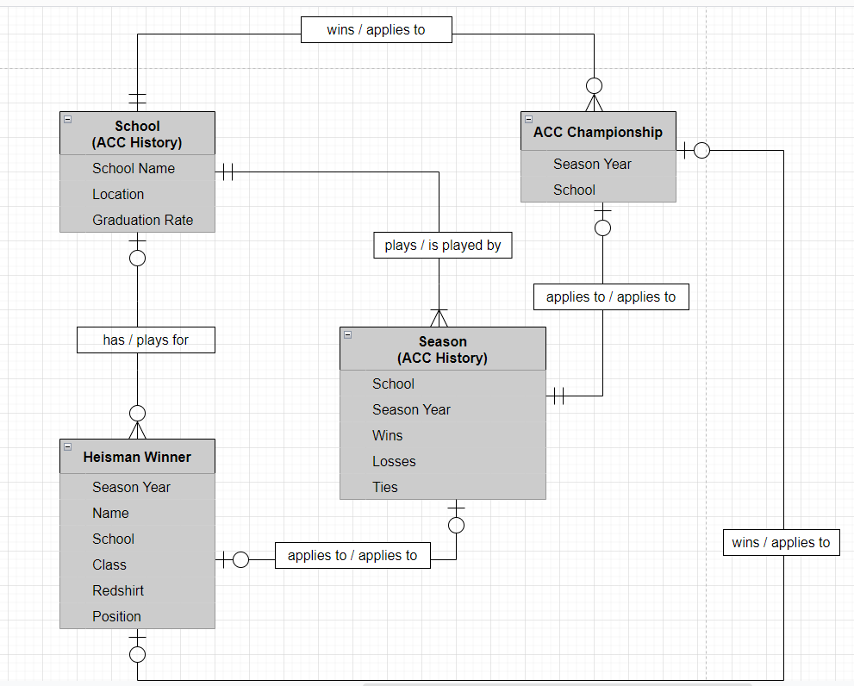

NORMALIZED LOGICAL MODEL

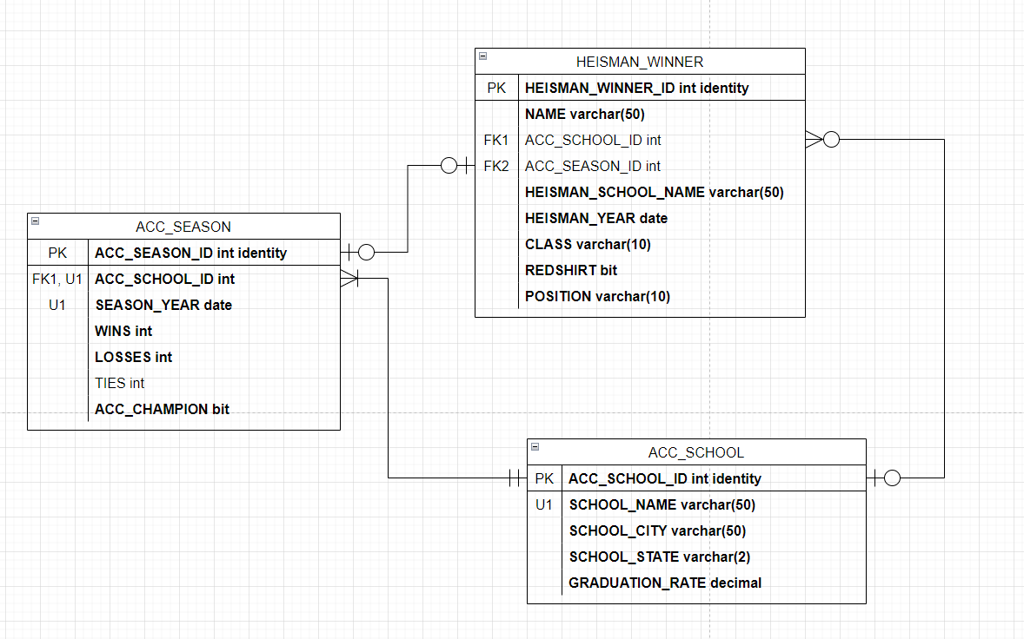

Data Definition Language (DDL)

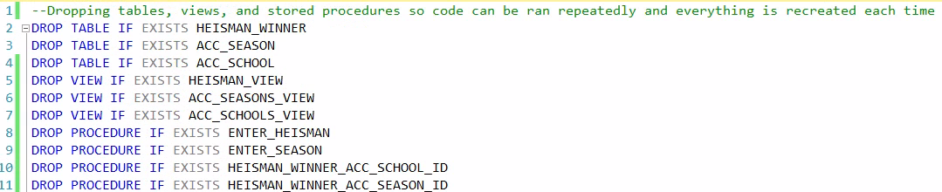

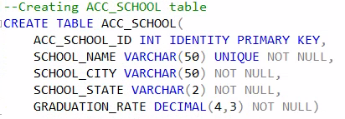

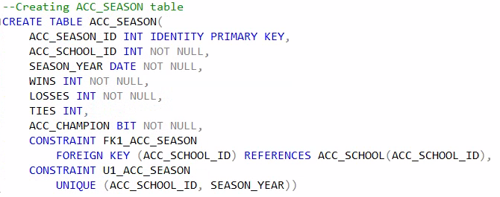

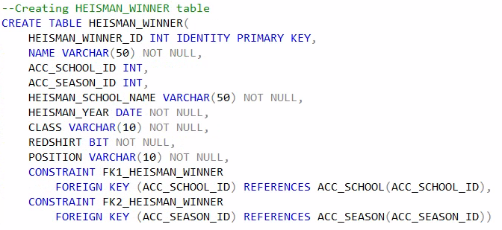

Data Manipulation Language (DML)

(All of ACC_SCHOOL)

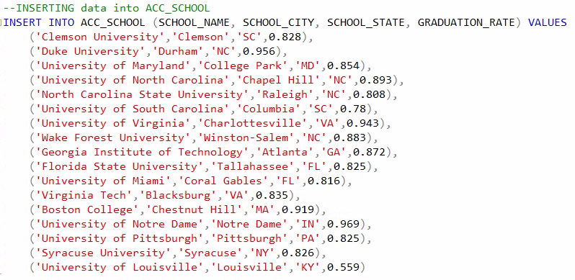

(Just the first few for HEISMAN_WINNER)

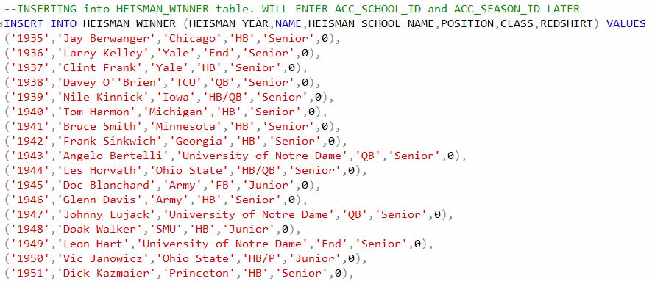

(Just the first few for ACC_SEASON)

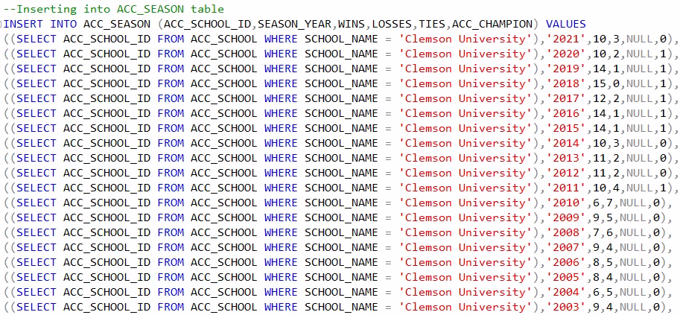

Tables and Views

ACC_SCHOOL

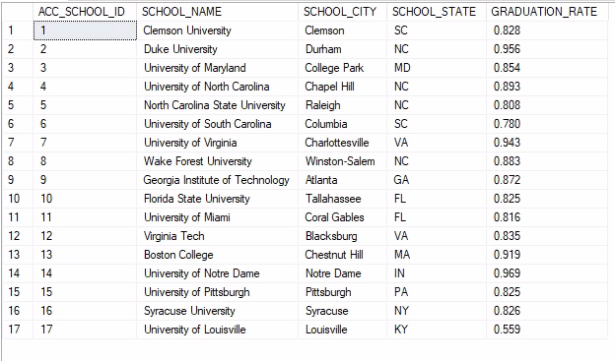

HEISMAN_WINNER (Just the first few records)

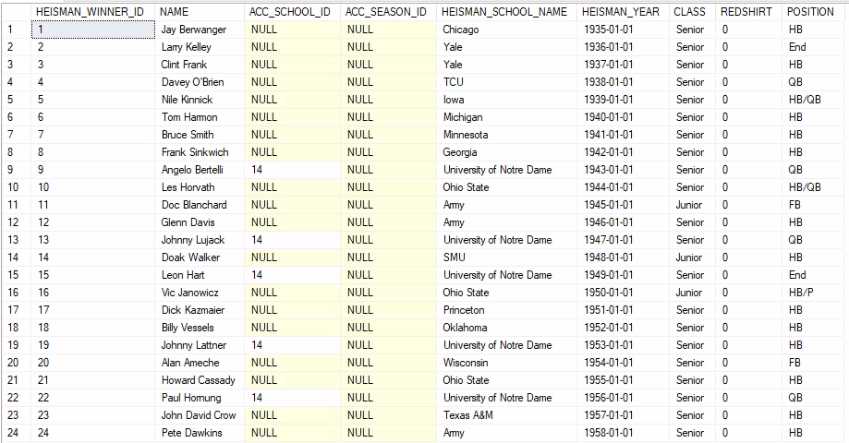

ACC_SEASON (Just the first few records)

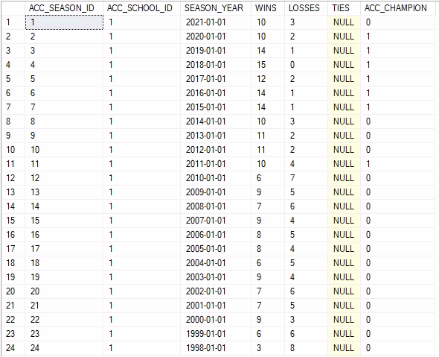

ACC_SCHOOLS_VIEW

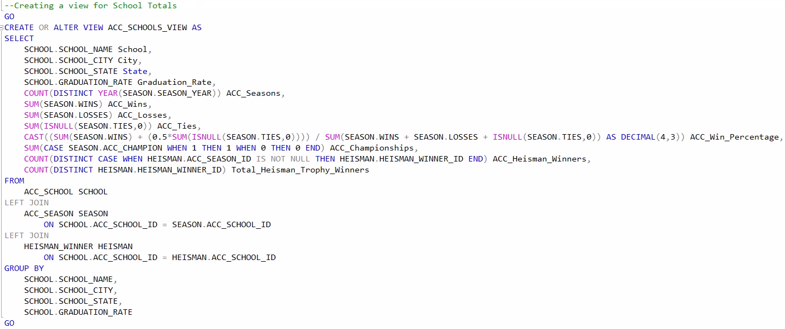

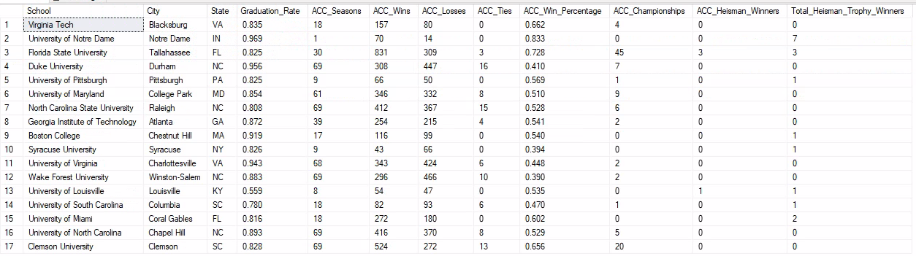

ACC_SEASONS_VIEW

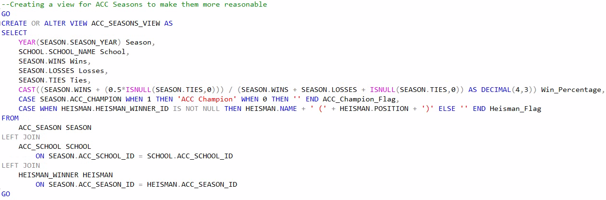

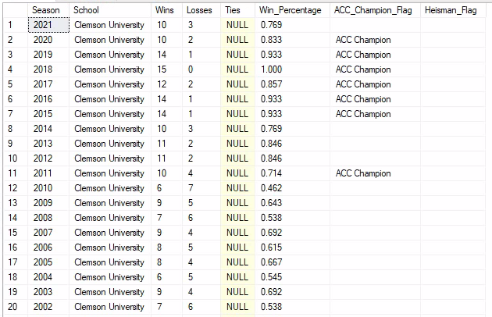

HEISMAN_VIEW

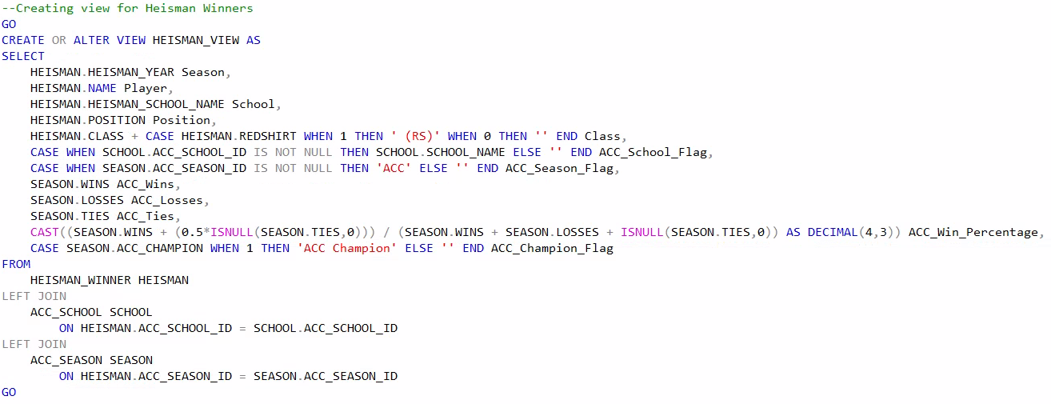

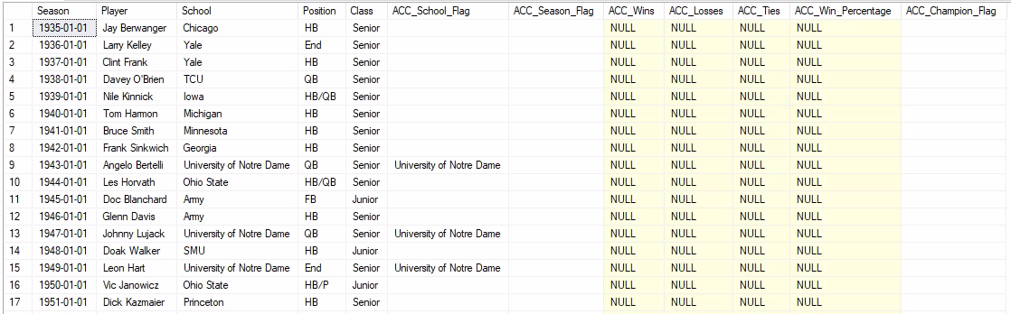

Programming Objects

HEISMAN_WINNER_ACC_SCHOOL_ID (Stored Procedure)

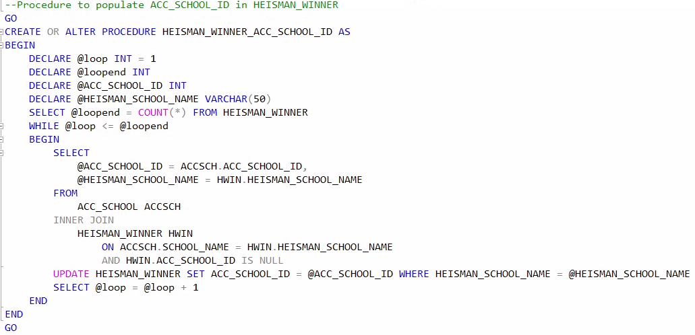

HEISMAN_WINNER_ACC_SEASON_ID (Stored Procedure)

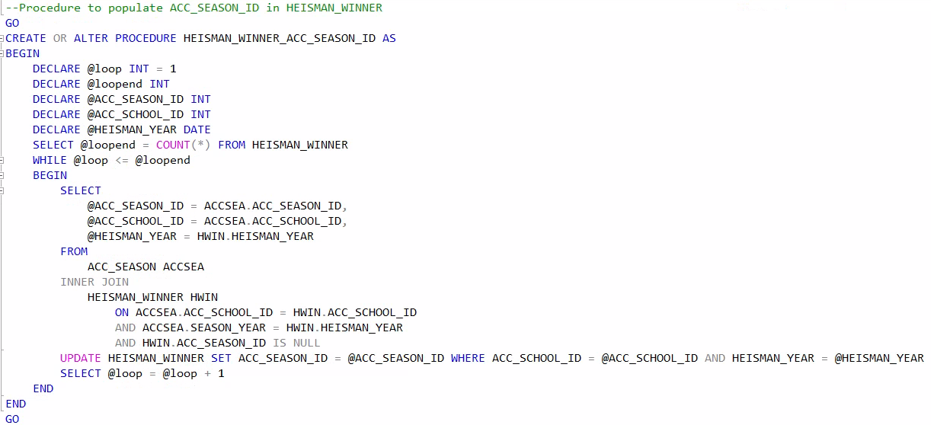

ENTER_HEISMAN (Stored Procedure)

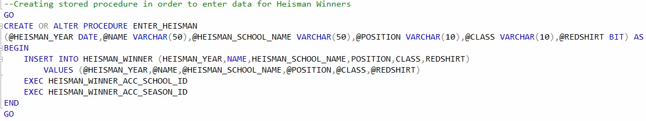

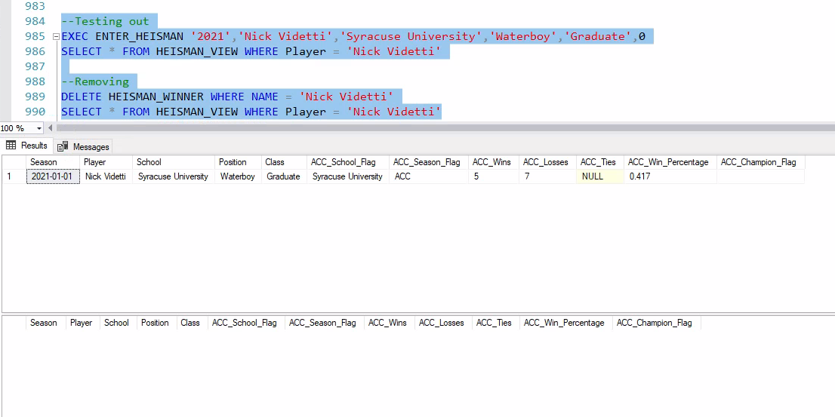

ENTER_SEASON (Stored Procedure)

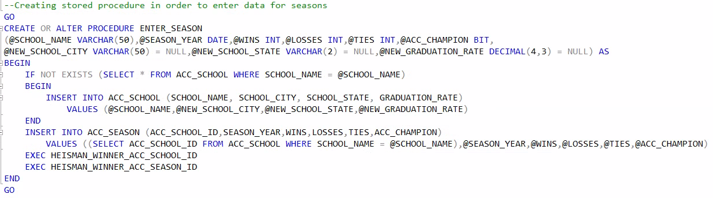

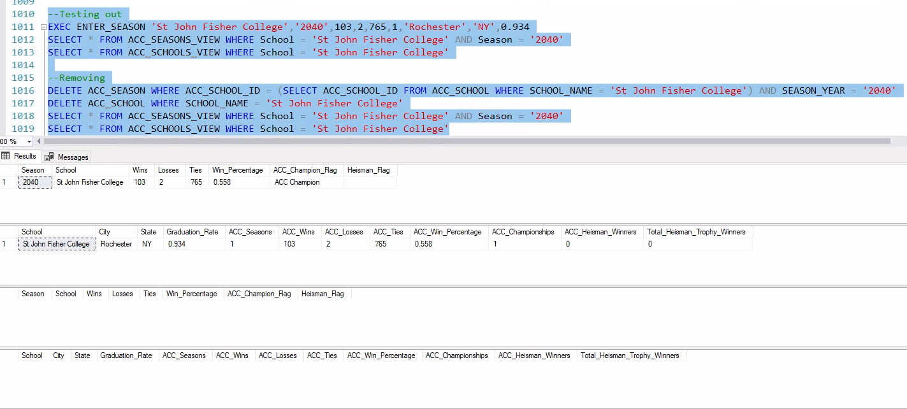

DATA SECURITY

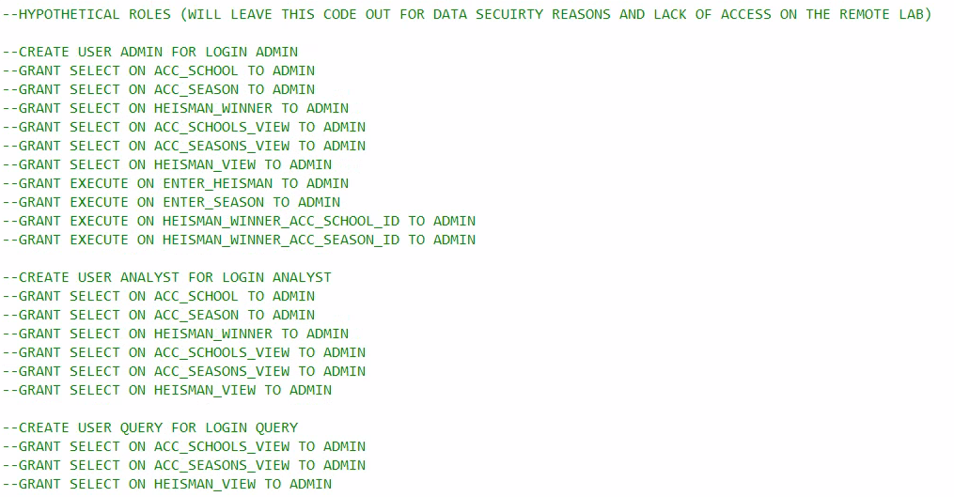

ANSWERING DATA QUESTIONS

Question 1

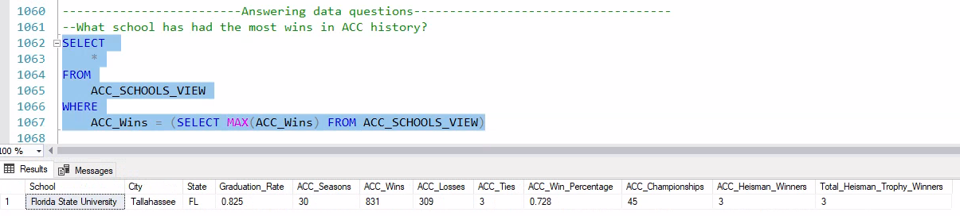

Question 2

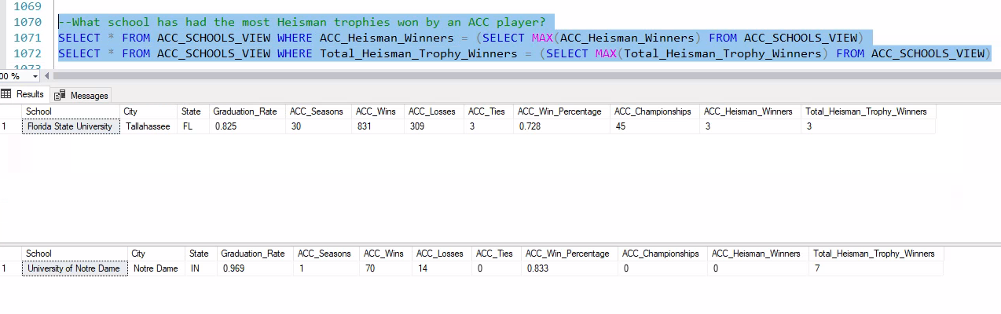

Question 3

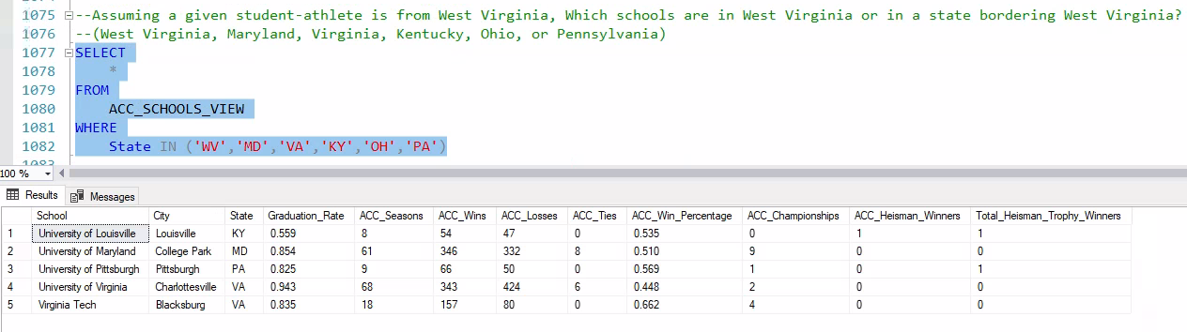

Question 4

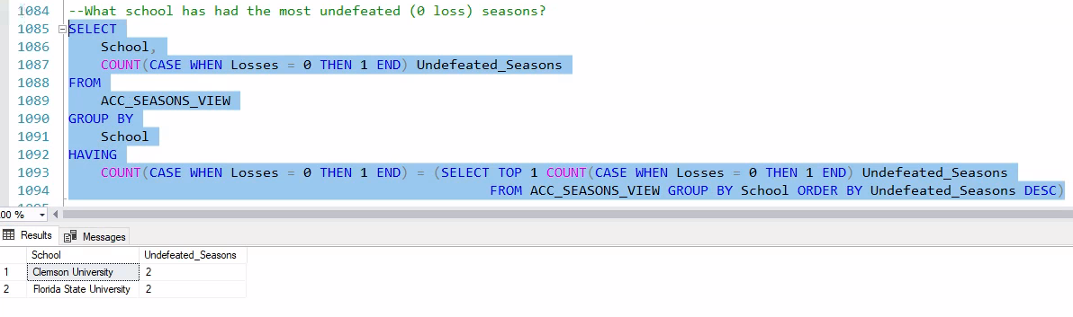

Question 5

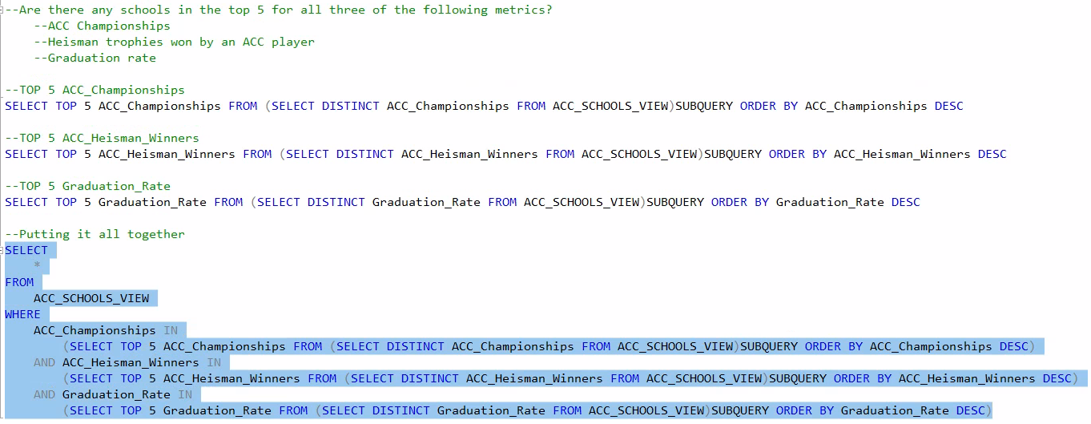



User Interface (Microsoft Access)

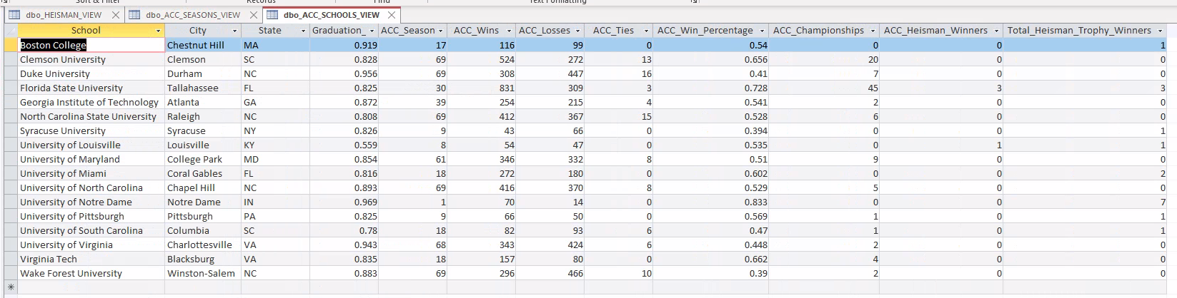

Reflection

This was a lot of fun to put together! There are a few things that surprised me along the way, one of which being that all of this only took three tables. Also, I do wish that I had more time to make sure that data entry went a bit smoother. While I don’t see a different way to approach it, data entry relies on making sure that the school name is an exact match to the current format of each school for existing schools. Ideally, there would be a different process, but I think a better way would be to create a different stored procedure or create some sort of code within the already created stored procedure that accounts for slightly misspelling school names, which currently results in the database treating it as a new school when we want it to instead detect that data entry error. Perhaps I could create another procedure that is only for entering seasons for schools that have never played an ACC season before and make the other procedure for entering seasons be only for schools that have played an ACC season before. This project definitely helped me implement what I learned this term to a somewhat real-world scenario, and that is very helpful for if and when I need to do database design/implementation in the future.

Full SQL Code

***--Dropping tables, views, and stored procedures so code can be ran repeatedly and everything is recreated each time***

***DROP TABLE IF EXISTS HEISMAN_WINNER***

***DROP TABLE IF EXISTS ACC_SEASON***

***DROP TABLE IF EXISTS ACC_SCHOOL***

***DROP VIEW IF EXISTS HEISMAN_VIEW***

***DROP VIEW IF EXISTS ACC_SEASONS_VIEW***

***DROP VIEW IF EXISTS ACC_SCHOOLS_VIEW***

***DROP PROCEDURE IF EXISTS ENTER_HEISMAN***

***DROP PROCEDURE IF EXISTS ENTER_SEASON***

***DROP PROCEDURE IF EXISTS HEISMAN_WINNER_ACC_SCHOOL_ID***

***DROP PROCEDURE IF EXISTS HEISMAN_WINNER_ACC_SEASON_ID***

***--Creating ACC_SCHOOL table***

***CREATE TABLE ACC_SCHOOL(***

***ACC_SCHOOL_ID INT IDENTITY PRIMARY KEY,***

***SCHOOL_NAME VARCHAR(50) UNIQUE NOT NULL,***

***SCHOOL_CITY VARCHAR(50) NOT NULL,***

***SCHOOL_STATE VARCHAR(2) NOT NULL,***

***GRADUATION_RATE DECIMAL(4,3) NOT NULL)***

***--Creating ACC_SEASON table***

***CREATE TABLE ACC_SEASON(***

***ACC_SEASON_ID INT IDENTITY PRIMARY KEY,***

***ACC_SCHOOL_ID INT NOT NULL,***

***SEASON_YEAR DATE NOT NULL,***

***WINS INT NOT NULL,***

***LOSSES INT NOT NULL,***

***TIES INT,***

***ACC_CHAMPION BIT NOT NULL,***

***CONSTRAINT FK1_ACC_SEASON***

***FOREIGN KEY (ACC_SCHOOL_ID) REFERENCES ACC_SCHOOL(ACC_SCHOOL_ID),***

***CONSTRAINT U1_ACC_SEASON***

***UNIQUE (ACC_SCHOOL_ID, SEASON_YEAR))***

***--Creating HEISMAN_WINNER table***

***CREATE TABLE HEISMAN_WINNER(***

***HEISMAN_WINNER_ID INT IDENTITY PRIMARY KEY,***

***NAME VARCHAR(50) NOT NULL,***

***ACC_SCHOOL_ID INT,***

***ACC_SEASON_ID INT,***

***HEISMAN_SCHOOL_NAME VARCHAR(50) NOT NULL,***

***HEISMAN_YEAR DATE NOT NULL,***

***CLASS VARCHAR(10) NOT NULL,***

***REDSHIRT BIT NOT NULL,***

***POSITION VARCHAR(10) NOT NULL,***

***CONSTRAINT FK1_HEISMAN_WINNER***

***FOREIGN KEY (ACC_SCHOOL_ID) REFERENCES ACC_SCHOOL(ACC_SCHOOL_ID),***

***CONSTRAINT FK2_HEISMAN_WINNER***

***FOREIGN KEY (ACC_SEASON_ID) REFERENCES ACC_SEASON(ACC_SEASON_ID))***

***--INSERTING data into ACC_SCHOOL***

***INSERT INTO ACC_SCHOOL (SCHOOL_NAME, SCHOOL_CITY, SCHOOL_STATE, GRADUATION_RATE) VALUES***

***('Clemson University','Clemson','SC',0.828),***

***('Duke University','Durham','NC',0.956),***

***('University of Maryland','College Park','MD',0.854),***

***('University of North Carolina','Chapel Hill','NC',0.893),***

***('North Carolina State University','Raleigh','NC',0.808),***

***('University of South Carolina','Columbia','SC',0.78),***

***('University of Virginia','Charlottesville','VA',0.943),***

***('Wake Forest University','Winston-Salem','NC',0.883),***

***('Georgia Institute of Technology','Atlanta','GA',0.872),***

***('Florida State University','Tallahassee','FL',0.825),***

***('University of Miami','Coral Gables','FL',0.816),***

***('Virginia Tech','Blacksburg','VA',0.835),***

***('Boston College','Chestnut Hill','MA',0.919),***

***('University of Notre Dame','Notre Dame','IN',0.969),***

***('University of Pittsburgh','Pittsburgh','PA',0.825),***

***('Syracuse University','Syracuse','NY',0.826),***

***('University of Louisville','Louisville','KY',0.559)***

***--Checking the results***

***SELECT * FROM ACC_SCHOOL***

***--INSERTING into HEISMAN_WINNER table. WILL ENTER ACC_SCHOOL_ID and ACC_SEASON_ID LATER***

***INSERT INTO HEISMAN_WINNER (HEISMAN_YEAR,NAME,HEISMAN_SCHOOL_NAME,POSITION,CLASS,REDSHIRT) VALUES***

***('1935','Jay Berwanger','Chicago','HB','Senior',0),***

***('1936','Larry Kelley','Yale','End','Senior',0),***

***('1937','Clint Frank','Yale','HB','Senior',0),***

***('1938','Davey O''Brien','TCU','QB','Senior',0),***

***('1939','Nile Kinnick','Iowa','HB/QB','Senior',0),***

***('1940','Tom Harmon','Michigan','HB','Senior',0),***

***('1941','Bruce Smith','Minnesota','HB','Senior',0),***

***('1942','Frank Sinkwich','Georgia','HB','Senior',0),***

***('1943','Angelo Bertelli','University of Notre Dame','QB','Senior',0),***

***('1944','Les Horvath','Ohio State','HB/QB','Senior',0),***

***('1945','Doc Blanchard','Army','FB','Junior',0),***

***('1946','Glenn Davis','Army','HB','Senior',0),***

***('1947','Johnny Lujack','University of Notre Dame','QB','Senior',0),***

***('1948','Doak Walker','SMU','HB','Junior',0),***

***('1949','Leon Hart','University of Notre Dame','End','Senior',0),***

***('1950','Vic Janowicz','Ohio State','HB/P','Junior',0),***

***('1951','Dick Kazmaier','Princeton','HB','Senior',0),***

***('1952','Billy Vessels','Oklahoma','HB','Senior',0),***

***('1953','Johnny Lattner','University of Notre Dame','HB','Senior',0),***

***('1954','Alan Ameche','Wisconsin','FB','Senior',0),***

***('1955','Howard Cassady','Ohio State','HB','Senior',0),***

***('1956','Paul Hornung','University of Notre Dame','QB','Senior',0),***

***('1957','John David Crow','Texas A&M','HB','Senior',0),***

***('1958','Pete Dawkins','Army','HB','Senior',0),***

***('1959','Billy Cannon','LSU','HB','Senior',0),***

***('1960','Joe Bellino','Navy','HB','Senior',0),***

***('1961','Ernie Davis','Syracuse University','HB/LB/FB','Senior',0),***

***('1962','Terry Baker','Oregon State','QB','Senior',0),***

***('1963','Roger Staubach','Navy','QB','Junior',0),***

***('1964','John Huarte','University of Notre Dame','QB','Senior',0),***

***('1965','Mike Garrett','USC','HB','Senior',0),***

***('1966','Steve Spurrier','Florida','QB','Senior',0),***

***('1967','Gary Beban','UCLA','QB','Senior',0),***

***('1968','O. J. Simpson','USC','HB','Senior',0),***

***('1969','Steve Owens','Oklahoma','FB','Senior',0),***

***('1970','Jim Plunkett','Stanford','QB','Senior',1),***

***('1971','Pat Sullivan','Auburn','QB','Senior',0),***

***('1972','Johnny Rodgers','Nebraska','WR/RB','Senior',0),***

***('1973','John Cappelletti','Penn State','RB','Senior',0),***

***('1974','Archie Griffin','Ohio State','RB','Junior',0),***

***('1975','Archie Griffin','Ohio State','RB','Senior',0),***

***('1976','Tony Dorsett','University of Pittsburgh','RB','Senior',0),***

***('1977','Earl Campbell','Texas','RB','Senior',0),***

***('1978','Billy Sims','Oklahoma','RB','Junior',1),***

***('1979','Charles White','USC','RB','Senior',0),***

***('1980','George Rogers','University of South Carolina','RB','Senior',0),***

***('1981','Marcus Allen','USC','RB','Senior',0),***

***('1982','Herschel Walker','Georgia','RB','Junior',0),***

***('1983','Mike Rozier','Nebraska','RB','Senior',0),***

***('1984','Doug Flutie','Boston College','QB','Senior',0),***

***('1985','Bo Jackson','Auburn','RB','Senior',0),***

***('1986','Vinny Testaverde','University of Miami','QB','Senior',1),***

***('1987','Tim Brown','University of Notre Dame','WR','Senior',0),***

***('1988','Barry Sanders','Oklahoma State','RB','Junior',0),***

***('1989','Andre Ware','Houston','QB','Junior',0),***

***('1990','Ty Detmer','BYU','QB','Junior',1),***

***('1991','Desmond Howard','Michigan','WR/PR','Junior',1),***

***('1992','Gino Torretta','University of Miami','QB','Senior',1),***

***('1993','Charlie Ward','Florida State University','QB','Senior',1),***

***('1994','Rashaan Salaam','Colorado','RB','Junior',0),***

***('1995','Eddie George','Ohio State','RB','Senior',0),***

***('1996','Danny Wuerffel','Florida','QB','Senior',1),***

***('1997','Charles Woodson','Michigan','CB','Junior',0),***

***('1998','Ricky Williams','Texas','RB','Senior',0),***

***('1999','Ron Dayne','Wisconsin','RB','Senior',0),***

***('2000','Chris Weinke','Florida State University','QB','Senior',0),***

***('2001','Eric Crouch','Nebraska','QB / WR','Senior',1),***

***('2002','Carson Palmer','USC','QB','Senior',1),***

***('2003','Jason White','Oklahoma','QB','Senior',1),***

***('2004','Matt Leinart','USC','QB','Junior',1),***

***('2006','Troy Smith','Ohio State','QB','Senior',1),***

***('2007','Tim Tebow','Florida','QB','Sophomore',0),***

***('2008','Sam Bradford','Oklahoma','QB','Sophomore',1),***

***('2009','Mark Ingram Jr.','Alabama','RB','Sophomore',0),***

***('2010','Cam Newton','Auburn','QB','Junior',1),***

***('2011','Robert Griffin III','Baylor','QB','Junior',1),***

***('2012','Johnny Manziel','Texas A&M','QB','Freshman',1),***

***('2013','Jameis Winston','Florida State University','QB','Freshman',1),***

***('2014','Marcus Mariota','Oregon','QB','Junior',1),***

***('2015','Derrick Henry','Alabama','RB','Junior',0),***

***('2016','Lamar Jackson','University of Louisville','QB','Sophomore',0),***

***('2017','Baker Mayfield','Oklahoma','QB','Senior',1),***

***('2018','Kyler Murray','Oklahoma','QB','Junior',1),***

***('2019','Joe Burrow','LSU','QB','Senior',1),***

***('2020','DeVonta Smith','Alabama','WR','Senior',0),***

***('2021','Bryce Young','Alabama','QB','Sophomore',0)***

***--Procedure to populate ACC_SCHOOL_ID in HEISMAN_WINNER***

***GO***

***CREATE OR ALTER PROCEDURE HEISMAN_WINNER_ACC_SCHOOL_ID AS***

***BEGIN***

***DECLARE @loop INT = 1***

***DECLARE @loopend INT***

***DECLARE @ACC_SCHOOL_ID INT***

***DECLARE @HEISMAN_SCHOOL_NAME VARCHAR(50)***

***SELECT @loopend = COUNT(*) FROM HEISMAN_WINNER***

***WHILE @loop <= @loopend***

***BEGIN***

***SELECT***

***@ACC_SCHOOL_ID = ACCSCH.ACC_SCHOOL_ID,***

***@HEISMAN_SCHOOL_NAME = HWIN.HEISMAN_SCHOOL_NAME***

***FROM***

***ACC_SCHOOL ACCSCH***

***INNER JOIN***

***HEISMAN_WINNER HWIN***

***ON ACCSCH.SCHOOL_NAME = HWIN.HEISMAN_SCHOOL_NAME***

***AND HWIN.ACC_SCHOOL_ID IS NULL***

***UPDATE HEISMAN_WINNER SET ACC_SCHOOL_ID = @ACC_SCHOOL_ID WHERE HEISMAN_SCHOOL_NAME = @HEISMAN_SCHOOL_NAME***

***SELECT @loop = @loop + 1***

***END***

***END***

***GO***

***--Implementing the procedure HEISMAN_WINNER_ACC_SCHOOL_ID***

***EXEC HEISMAN_WINNER_ACC_SCHOOL_ID***

***--Checking the results***

***SELECT * FROM HEISMAN_WINNER***

***--Inserting into ACC_SEASON table***

***INSERT INTO ACC_SEASON (ACC_SCHOOL_ID,SEASON_YEAR,WINS,LOSSES,TIES,ACC_CHAMPION) VALUES***

***((SELECT ACC_SCHOOL_ID FROM ACC_SCHOOL WHERE SCHOOL_NAME = 'Clemson University'),'2021',10,3,NULL,0),***

***((SELECT ACC_SCHOOL_ID FROM ACC_SCHOOL WHERE SCHOOL_NAME = 'Clemson University'),'2020',10,2,NULL,1),***

***((SELECT ACC_SCHOOL_ID FROM ACC_SCHOOL WHERE SCHOOL_NAME = 'Clemson University'),'2019',14,1,NULL,1),***

***((SELECT ACC_SCHOOL_ID FROM ACC_SCHOOL WHERE SCHOOL_NAME = 'Clemson University'),'2018',15,0,NULL,1),***

***((SELECT ACC_SCHOOL_ID FROM ACC_SCHOOL WHERE SCHOOL_NAME = 'Clemson University'),'2017',12,2,NULL,1),***

***((SELECT ACC_SCHOOL_ID FROM ACC_SCHOOL WHERE SCHOOL_NAME = 'Clemson University'),'2016',14,1,NULL,1),***

***((SELECT ACC_SCHOOL_ID FROM ACC_SCHOOL WHERE SCHOOL_NAME = 'Clemson University'),'2015',14,1,NULL,1),***

***((SELECT ACC_SCHOOL_ID FROM ACC_SCHOOL WHERE SCHOOL_NAME = 'Clemson University'),'2014',10,3,NULL,0),***

***((SELECT ACC_SCHOOL_ID FROM ACC_SCHOOL WHERE SCHOOL_NAME = 'Clemson University'),'2013',11,2,NULL,0),***

***((SELECT ACC_SCHOOL_ID FROM ACC_SCHOOL WHERE SCHOOL_NAME = 'Clemson University'),'2012',11,2,NULL,0),***

***((SELECT ACC_SCHOOL_ID FROM ACC_SCHOOL WHERE SCHOOL_NAME = 'Clemson University'),'2011',10,4,NULL,1),***

***((SELECT ACC_SCHOOL_ID FROM ACC_SCHOOL WHERE SCHOOL_NAME = 'Clemson University'),'2010',6,7,NULL,0),***

***((SELECT ACC_SCHOOL_ID FROM ACC_SCHOOL WHERE SCHOOL_NAME = 'Clemson University'),'2009',9,5,NULL,0),***

***((SELECT ACC_SCHOOL_ID FROM ACC_SCHOOL WHERE SCHOOL_NAME = 'Clemson University'),'2008',7,6,NULL,0),***

***((SELECT ACC_SCHOOL_ID FROM ACC_SCHOOL WHERE SCHOOL_NAME = 'Clemson University'),'2007',9,4,NULL,0),***

***((SELECT ACC_SCHOOL_ID FROM ACC_SCHOOL WHERE SCHOOL_NAME = 'Clemson University'),'2006',8,5,NULL,0),***

***((SELECT ACC_SCHOOL_ID FROM ACC_SCHOOL WHERE SCHOOL_NAME = 'Clemson University'),'2005',8,4,NULL,0),***

***((SELECT ACC_SCHOOL_ID FROM ACC_SCHOOL WHERE SCHOOL_NAME = 'Clemson University'),'2004',6,5,NULL,0),***

***((SELECT ACC_SCHOOL_ID FROM ACC_SCHOOL WHERE SCHOOL_NAME = 'Clemson University'),'2003',9,4,NULL,0),***

***((SELECT ACC_SCHOOL_ID FROM ACC_SCHOOL WHERE SCHOOL_NAME = 'Clemson University'),'2002',7,6,NULL,0),***

***((SELECT ACC_SCHOOL_ID FROM ACC_SCHOOL WHERE SCHOOL_NAME = 'Clemson University'),'2001',7,5,NULL,0),***

***((SELECT ACC_SCHOOL_ID FROM ACC_SCHOOL WHERE SCHOOL_NAME = 'Clemson University'),'2000',9,3,NULL,0),***

***((SELECT ACC_SCHOOL_ID FROM ACC_SCHOOL WHERE SCHOOL_NAME = 'Clemson University'),'1999',6,6,NULL,0),***

***((SELECT ACC_SCHOOL_ID FROM ACC_SCHOOL WHERE SCHOOL_NAME = 'Clemson University'),'1998',3,8,NULL,0),***

***((SELECT ACC_SCHOOL_ID FROM ACC_SCHOOL WHERE SCHOOL_NAME = 'Clemson University'),'1997',7,5,NULL,0),***

***((SELECT ACC_SCHOOL_ID FROM ACC_SCHOOL WHERE SCHOOL_NAME = 'Clemson University'),'1996',7,5,NULL,0),***

***((SELECT ACC_SCHOOL_ID FROM ACC_SCHOOL WHERE SCHOOL_NAME = 'Clemson University'),'1995',8,4,NULL,0),***

***((SELECT ACC_SCHOOL_ID FROM ACC_SCHOOL WHERE SCHOOL_NAME = 'Clemson University'),'1994',5,6,NULL,0),***

***((SELECT ACC_SCHOOL_ID FROM ACC_SCHOOL WHERE SCHOOL_NAME = 'Clemson University'),'1993',9,3,NULL,0),***

***((SELECT ACC_SCHOOL_ID FROM ACC_SCHOOL WHERE SCHOOL_NAME = 'Clemson University'),'1992',5,6,NULL,0),***

***((SELECT ACC_SCHOOL_ID FROM ACC_SCHOOL WHERE SCHOOL_NAME = 'Clemson University'),'1991',9,2,1,1),***

***((SELECT ACC_SCHOOL_ID FROM ACC_SCHOOL WHERE SCHOOL_NAME = 'Clemson University'),'1990',10,2,NULL,0),***

***((SELECT ACC_SCHOOL_ID FROM ACC_SCHOOL WHERE SCHOOL_NAME = 'Clemson University'),'1989',10,2,NULL,0),***

***((SELECT ACC_SCHOOL_ID FROM ACC_SCHOOL WHERE SCHOOL_NAME = 'Clemson University'),'1988',10,2,NULL,1),***

***((SELECT ACC_SCHOOL_ID FROM ACC_SCHOOL WHERE SCHOOL_NAME = 'Clemson University'),'1987',10,2,NULL,1),***

***((SELECT ACC_SCHOOL_ID FROM ACC_SCHOOL WHERE SCHOOL_NAME = 'Clemson University'),'1986',8,2,2,1),***

***((SELECT ACC_SCHOOL_ID FROM ACC_SCHOOL WHERE SCHOOL_NAME = 'Clemson University'),'1985',6,6,NULL,0),***

***((SELECT ACC_SCHOOL_ID FROM ACC_SCHOOL WHERE SCHOOL_NAME = 'Clemson University'),'1984',7,4,NULL,0),***

***((SELECT ACC_SCHOOL_ID FROM ACC_SCHOOL WHERE SCHOOL_NAME = 'Clemson University'),'1983',9,1,1,0),***

***((SELECT ACC_SCHOOL_ID FROM ACC_SCHOOL WHERE SCHOOL_NAME = 'Clemson University'),'1982',9,1,1,1),***

***((SELECT ACC_SCHOOL_ID FROM ACC_SCHOOL WHERE SCHOOL_NAME = 'Clemson University'),'1981',12,0,NULL,1),***

***((SELECT ACC_SCHOOL_ID FROM ACC_SCHOOL WHERE SCHOOL_NAME = 'Clemson University'),'1980',6,5,NULL,0),***

***((SELECT ACC_SCHOOL_ID FROM ACC_SCHOOL WHERE SCHOOL_NAME = 'Clemson University'),'1979',8,4,NULL,0),***

***((SELECT ACC_SCHOOL_ID FROM ACC_SCHOOL WHERE SCHOOL_NAME = 'Clemson University'),'1978',11,1,NULL,1),***

***((SELECT ACC_SCHOOL_ID FROM ACC_SCHOOL WHERE SCHOOL_NAME = 'Clemson University'),'1977',8,3,1,0),***

***((SELECT ACC_SCHOOL_ID FROM ACC_SCHOOL WHERE SCHOOL_NAME = 'Clemson University'),'1976',3,6,2,0),***

***((SELECT ACC_SCHOOL_ID FROM ACC_SCHOOL WHERE SCHOOL_NAME = 'Clemson University'),'1975',2,9,NULL,0),***

***((SELECT ACC_SCHOOL_ID FROM ACC_SCHOOL WHERE SCHOOL_NAME = 'Clemson University'),'1974',7,4,NULL,0),***

***((SELECT ACC_SCHOOL_ID FROM ACC_SCHOOL WHERE SCHOOL_NAME = 'Clemson University'),'1973',5,6,NULL,0),***

***((SELECT ACC_SCHOOL_ID FROM ACC_SCHOOL WHERE SCHOOL_NAME = 'Clemson University'),'1972',4,7,NULL,0),***

***((SELECT ACC_SCHOOL_ID FROM ACC_SCHOOL WHERE SCHOOL_NAME = 'Clemson University'),'1971',5,6,NULL,0),***

***((SELECT ACC_SCHOOL_ID FROM ACC_SCHOOL WHERE SCHOOL_NAME = 'Clemson University'),'1970',3,8,NULL,0),***

***((SELECT ACC_SCHOOL_ID FROM ACC_SCHOOL WHERE SCHOOL_NAME = 'Clemson University'),'1969',4,6,NULL,0),***

***((SELECT ACC_SCHOOL_ID FROM ACC_SCHOOL WHERE SCHOOL_NAME = 'Clemson University'),'1968',4,5,1,0),***

***((SELECT ACC_SCHOOL_ID FROM ACC_SCHOOL WHERE SCHOOL_NAME = 'Clemson University'),'1967',6,4,NULL,1),***

***((SELECT ACC_SCHOOL_ID FROM ACC_SCHOOL WHERE SCHOOL_NAME = 'Clemson University'),'1966',6,4,NULL,1),***

***((SELECT ACC_SCHOOL_ID FROM ACC_SCHOOL WHERE SCHOOL_NAME = 'Clemson University'),'1965',5,5,NULL,1),***

***((SELECT ACC_SCHOOL_ID FROM ACC_SCHOOL WHERE SCHOOL_NAME = 'Clemson University'),'1964',3,7,NULL,0),***

***((SELECT ACC_SCHOOL_ID FROM ACC_SCHOOL WHERE SCHOOL_NAME = 'Clemson University'),'1963',5,4,1,0),***

***((SELECT ACC_SCHOOL_ID FROM ACC_SCHOOL WHERE SCHOOL_NAME = 'Clemson University'),'1962',6,4,NULL,0),***

***((SELECT ACC_SCHOOL_ID FROM ACC_SCHOOL WHERE SCHOOL_NAME = 'Clemson University'),'1961',5,5,NULL,0),***

***((SELECT ACC_SCHOOL_ID FROM ACC_SCHOOL WHERE SCHOOL_NAME = 'Clemson University'),'1960',6,4,NULL,0),***

***((SELECT ACC_SCHOOL_ID FROM ACC_SCHOOL WHERE SCHOOL_NAME = 'Clemson University'),'1959',9,2,NULL,1),***

***((SELECT ACC_SCHOOL_ID FROM ACC_SCHOOL WHERE SCHOOL_NAME = 'Clemson University'),'1958',8,3,NULL,1),***

***((SELECT ACC_SCHOOL_ID FROM ACC_SCHOOL WHERE SCHOOL_NAME = 'Clemson University'),'1957',7,3,NULL,0),***

***((SELECT ACC_SCHOOL_ID FROM ACC_SCHOOL WHERE SCHOOL_NAME = 'Clemson University'),'1956',7,2,2,1),***

***((SELECT ACC_SCHOOL_ID FROM ACC_SCHOOL WHERE SCHOOL_NAME = 'Clemson University'),'1955',7,3,NULL,0),***

***((SELECT ACC_SCHOOL_ID FROM ACC_SCHOOL WHERE SCHOOL_NAME = 'Clemson University'),'1954',5,5,NULL,0),***

***((SELECT ACC_SCHOOL_ID FROM ACC_SCHOOL WHERE SCHOOL_NAME = 'Clemson University'),'1953',3,5,1,0),***

***((SELECT ACC_SCHOOL_ID FROM ACC_SCHOOL WHERE SCHOOL_NAME = 'Duke University'),'2021',3,9,NULL,0),***

***((SELECT ACC_SCHOOL_ID FROM ACC_SCHOOL WHERE SCHOOL_NAME = 'Duke University'),'2020',2,9,NULL,0),***

***((SELECT ACC_SCHOOL_ID FROM ACC_SCHOOL WHERE SCHOOL_NAME = 'Duke University'),'2019',5,7,NULL,0),***

***((SELECT ACC_SCHOOL_ID FROM ACC_SCHOOL WHERE SCHOOL_NAME = 'Duke University'),'2018',8,5,NULL,0),***

***((SELECT ACC_SCHOOL_ID FROM ACC_SCHOOL WHERE SCHOOL_NAME = 'Duke University'),'2017',7,6,NULL,0),***

***((SELECT ACC_SCHOOL_ID FROM ACC_SCHOOL WHERE SCHOOL_NAME = 'Duke University'),'2016',4,8,NULL,0),***

***((SELECT ACC_SCHOOL_ID FROM ACC_SCHOOL WHERE SCHOOL_NAME = 'Duke University'),'2015',8,5,NULL,0),***

***((SELECT ACC_SCHOOL_ID FROM ACC_SCHOOL WHERE SCHOOL_NAME = 'Duke University'),'2014',9,4,NULL,0),***

***((SELECT ACC_SCHOOL_ID FROM ACC_SCHOOL WHERE SCHOOL_NAME = 'Duke University'),'2013',10,4,NULL,0),***

***((SELECT ACC_SCHOOL_ID FROM ACC_SCHOOL WHERE SCHOOL_NAME = 'Duke University'),'2012',6,7,NULL,0),***

***((SELECT ACC_SCHOOL_ID FROM ACC_SCHOOL WHERE SCHOOL_NAME = 'Duke University'),'2011',3,9,NULL,0),***

***((SELECT ACC_SCHOOL_ID FROM ACC_SCHOOL WHERE SCHOOL_NAME = 'Duke University'),'2010',3,9,NULL,0),***

***((SELECT ACC_SCHOOL_ID FROM ACC_SCHOOL WHERE SCHOOL_NAME = 'Duke University'),'2009',5,7,NULL,0),***

***((SELECT ACC_SCHOOL_ID FROM ACC_SCHOOL WHERE SCHOOL_NAME = 'Duke University'),'2008',4,8,NULL,0),***

***((SELECT ACC_SCHOOL_ID FROM ACC_SCHOOL WHERE SCHOOL_NAME = 'Duke University'),'2007',1,11,NULL,0),***

***((SELECT ACC_SCHOOL_ID FROM ACC_SCHOOL WHERE SCHOOL_NAME = 'Duke University'),'2006',0,12,NULL,0),***

***((SELECT ACC_SCHOOL_ID FROM ACC_SCHOOL WHERE SCHOOL_NAME = 'Duke University'),'2005',1,10,NULL,0),***

***((SELECT ACC_SCHOOL_ID FROM ACC_SCHOOL WHERE SCHOOL_NAME = 'Duke University'),'2004',2,9,NULL,0),***

***((SELECT ACC_SCHOOL_ID FROM ACC_SCHOOL WHERE SCHOOL_NAME = 'Duke University'),'2003',4,8,NULL,0),***

***((SELECT ACC_SCHOOL_ID FROM ACC_SCHOOL WHERE SCHOOL_NAME = 'Duke University'),'2002',2,10,NULL,0),***

***((SELECT ACC_SCHOOL_ID FROM ACC_SCHOOL WHERE SCHOOL_NAME = 'Duke University'),'2001',0,11,NULL,0),***

***((SELECT ACC_SCHOOL_ID FROM ACC_SCHOOL WHERE SCHOOL_NAME = 'Duke University'),'2000',0,11,NULL,0),***

***((SELECT ACC_SCHOOL_ID FROM ACC_SCHOOL WHERE SCHOOL_NAME = 'Duke University'),'1999',3,8,NULL,0),***

***((SELECT ACC_SCHOOL_ID FROM ACC_SCHOOL WHERE SCHOOL_NAME = 'Duke University'),'1998',4,7,NULL,0),***

***((SELECT ACC_SCHOOL_ID FROM ACC_SCHOOL WHERE SCHOOL_NAME = 'Duke University'),'1997',2,9,NULL,0),***

***((SELECT ACC_SCHOOL_ID FROM ACC_SCHOOL WHERE SCHOOL_NAME = 'Duke University'),'1996',0,11,NULL,0),***

***((SELECT ACC_SCHOOL_ID FROM ACC_SCHOOL WHERE SCHOOL_NAME = 'Duke University'),'1995',3,8,NULL,0),***

***((SELECT ACC_SCHOOL_ID FROM ACC_SCHOOL WHERE SCHOOL_NAME = 'Duke University'),'1994',8,4,NULL,0),***

***((SELECT ACC_SCHOOL_ID FROM ACC_SCHOOL WHERE SCHOOL_NAME = 'Duke University'),'1993',3,8,NULL,0),***

***((SELECT ACC_SCHOOL_ID FROM ACC_SCHOOL WHERE SCHOOL_NAME = 'Duke University'),'1992',2,9,NULL,0),***

***((SELECT ACC_SCHOOL_ID FROM ACC_SCHOOL WHERE SCHOOL_NAME = 'Duke University'),'1991',4,6,1,0),***

***((SELECT ACC_SCHOOL_ID FROM ACC_SCHOOL WHERE SCHOOL_NAME = 'Duke University'),'1990',4,7,NULL,0),***

***((SELECT ACC_SCHOOL_ID FROM ACC_SCHOOL WHERE SCHOOL_NAME = 'Duke University'),'1989',8,4,NULL,1),***

***((SELECT ACC_SCHOOL_ID FROM ACC_SCHOOL WHERE SCHOOL_NAME = 'Duke University'),'1988',7,3,1,0),***

***((SELECT ACC_SCHOOL_ID FROM ACC_SCHOOL WHERE SCHOOL_NAME = 'Duke University'),'1987',5,6,NULL,0),***

***((SELECT ACC_SCHOOL_ID FROM ACC_SCHOOL WHERE SCHOOL_NAME = 'Duke University'),'1986',4,7,NULL,0),***

***((SELECT ACC_SCHOOL_ID FROM ACC_SCHOOL WHERE SCHOOL_NAME = 'Duke University'),'1985',4,7,NULL,0),***

***((SELECT ACC_SCHOOL_ID FROM ACC_SCHOOL WHERE SCHOOL_NAME = 'Duke University'),'1984',2,9,NULL,0),***

***((SELECT ACC_SCHOOL_ID FROM ACC_SCHOOL WHERE SCHOOL_NAME = 'Duke University'),'1983',3,8,NULL,0),***

***((SELECT ACC_SCHOOL_ID FROM ACC_SCHOOL WHERE SCHOOL_NAME = 'Duke University'),'1982',6,5,NULL,0),***

***((SELECT ACC_SCHOOL_ID FROM ACC_SCHOOL WHERE SCHOOL_NAME = 'Duke University'),'1981',6,5,NULL,0),***

***((SELECT ACC_SCHOOL_ID FROM ACC_SCHOOL WHERE SCHOOL_NAME = 'Duke University'),'1980',2,9,NULL,0),***

***((SELECT ACC_SCHOOL_ID FROM ACC_SCHOOL WHERE SCHOOL_NAME = 'Duke University'),'1979',2,8,1,0),***

***((SELECT ACC_SCHOOL_ID FROM ACC_SCHOOL WHERE SCHOOL_NAME = 'Duke University'),'1978',4,7,NULL,0),***

***((SELECT ACC_SCHOOL_ID FROM ACC_SCHOOL WHERE SCHOOL_NAME = 'Duke University'),'1977',5,6,NULL,0),***

***((SELECT ACC_SCHOOL_ID FROM ACC_SCHOOL WHERE SCHOOL_NAME = 'Duke University'),'1976',5,5,1,0),***

***((SELECT ACC_SCHOOL_ID FROM ACC_SCHOOL WHERE SCHOOL_NAME = 'Duke University'),'1975',4,5,2,0),***

***((SELECT ACC_SCHOOL_ID FROM ACC_SCHOOL WHERE SCHOOL_NAME = 'Duke University'),'1974',6,5,NULL,0),***

***((SELECT ACC_SCHOOL_ID FROM ACC_SCHOOL WHERE SCHOOL_NAME = 'Duke University'),'1973',2,8,1,0),***

***((SELECT ACC_SCHOOL_ID FROM ACC_SCHOOL WHERE SCHOOL_NAME = 'Duke University'),'1972',5,6,NULL,0),***

***((SELECT ACC_SCHOOL_ID FROM ACC_SCHOOL WHERE SCHOOL_NAME = 'Duke University'),'1971',6,5,NULL,0),***

***((SELECT ACC_SCHOOL_ID FROM ACC_SCHOOL WHERE SCHOOL_NAME = 'Duke University'),'1970',6,5,NULL,0),***

***((SELECT ACC_SCHOOL_ID FROM ACC_SCHOOL WHERE SCHOOL_NAME = 'Duke University'),'1969',3,6,1,0),***

***((SELECT ACC_SCHOOL_ID FROM ACC_SCHOOL WHERE SCHOOL_NAME = 'Duke University'),'1968',4,6,NULL,0),***

***((SELECT ACC_SCHOOL_ID FROM ACC_SCHOOL WHERE SCHOOL_NAME = 'Duke University'),'1967',4,6,NULL,0),***

***((SELECT ACC_SCHOOL_ID FROM ACC_SCHOOL WHERE SCHOOL_NAME = 'Duke University'),'1966',5,5,NULL,0),***

***((SELECT ACC_SCHOOL_ID FROM ACC_SCHOOL WHERE SCHOOL_NAME = 'Duke University'),'1965',6,4,NULL,0),***

***((SELECT ACC_SCHOOL_ID FROM ACC_SCHOOL WHERE SCHOOL_NAME = 'Duke University'),'1964',4,5,1,0),***

***((SELECT ACC_SCHOOL_ID FROM ACC_SCHOOL WHERE SCHOOL_NAME = 'Duke University'),'1963',5,4,1,0),***

***((SELECT ACC_SCHOOL_ID FROM ACC_SCHOOL WHERE SCHOOL_NAME = 'Duke University'),'1962',8,2,NULL,1),***

***((SELECT ACC_SCHOOL_ID FROM ACC_SCHOOL WHERE SCHOOL_NAME = 'Duke University'),'1961',7,3,NULL,1),***

***((SELECT ACC_SCHOOL_ID FROM ACC_SCHOOL WHERE SCHOOL_NAME = 'Duke University'),'1960',8,3,NULL,1),***

***((SELECT ACC_SCHOOL_ID FROM ACC_SCHOOL WHERE SCHOOL_NAME = 'Duke University'),'1959',4,6,NULL,0),***

***((SELECT ACC_SCHOOL_ID FROM ACC_SCHOOL WHERE SCHOOL_NAME = 'Duke University'),'1958',5,5,NULL,0),***

***((SELECT ACC_SCHOOL_ID FROM ACC_SCHOOL WHERE SCHOOL_NAME = 'Duke University'),'1957',6,3,2,0),***

***((SELECT ACC_SCHOOL_ID FROM ACC_SCHOOL WHERE SCHOOL_NAME = 'Duke University'),'1956',5,4,1,0),***

***((SELECT ACC_SCHOOL_ID FROM ACC_SCHOOL WHERE SCHOOL_NAME = 'Duke University'),'1955',7,2,1,1),***

***((SELECT ACC_SCHOOL_ID FROM ACC_SCHOOL WHERE SCHOOL_NAME = 'Duke University'),'1954',8,2,1,1),***

***((SELECT ACC_SCHOOL_ID FROM ACC_SCHOOL WHERE SCHOOL_NAME = 'Duke University'),'1953',7,2,1,1),***

***((SELECT ACC_SCHOOL_ID FROM ACC_SCHOOL WHERE SCHOOL_NAME = 'University of Maryland'),'2013',7,6,NULL,0),***

***((SELECT ACC_SCHOOL_ID FROM ACC_SCHOOL WHERE SCHOOL_NAME = 'University of Maryland'),'2012',4,8,NULL,0),***

***((SELECT ACC_SCHOOL_ID FROM ACC_SCHOOL WHERE SCHOOL_NAME = 'University of Maryland'),'2011',2,10,NULL,0),***

***((SELECT ACC_SCHOOL_ID FROM ACC_SCHOOL WHERE SCHOOL_NAME = 'University of Maryland'),'2010',9,4,NULL,0),***

***((SELECT ACC_SCHOOL_ID FROM ACC_SCHOOL WHERE SCHOOL_NAME = 'University of Maryland'),'2009',2,10,NULL,0),***

***((SELECT ACC_SCHOOL_ID FROM ACC_SCHOOL WHERE SCHOOL_NAME = 'University of Maryland'),'2008',8,5,NULL,0),***

***((SELECT ACC_SCHOOL_ID FROM ACC_SCHOOL WHERE SCHOOL_NAME = 'University of Maryland'),'2007',6,7,NULL,0),***

***((SELECT ACC_SCHOOL_ID FROM ACC_SCHOOL WHERE SCHOOL_NAME = 'University of Maryland'),'2006',9,4,NULL,0),***

***((SELECT ACC_SCHOOL_ID FROM ACC_SCHOOL WHERE SCHOOL_NAME = 'University of Maryland'),'2005',5,6,NULL,0),***

***((SELECT ACC_SCHOOL_ID FROM ACC_SCHOOL WHERE SCHOOL_NAME = 'University of Maryland'),'2004',5,6,NULL,0),***

***((SELECT ACC_SCHOOL_ID FROM ACC_SCHOOL WHERE SCHOOL_NAME = 'University of Maryland'),'2003',10,3,NULL,0),***

***((SELECT ACC_SCHOOL_ID FROM ACC_SCHOOL WHERE SCHOOL_NAME = 'University of Maryland'),'2002',11,3,NULL,0),***

***((SELECT ACC_SCHOOL_ID FROM ACC_SCHOOL WHERE SCHOOL_NAME = 'University of Maryland'),'2001',10,2,NULL,1),***

***((SELECT ACC_SCHOOL_ID FROM ACC_SCHOOL WHERE SCHOOL_NAME = 'University of Maryland'),'2000',5,6,NULL,0),***

***((SELECT ACC_SCHOOL_ID FROM ACC_SCHOOL WHERE SCHOOL_NAME = 'University of Maryland'),'1999',5,6,NULL,0),***

***((SELECT ACC_SCHOOL_ID FROM ACC_SCHOOL WHERE SCHOOL_NAME = 'University of Maryland'),'1998',3,8,NULL,0),***

***((SELECT ACC_SCHOOL_ID FROM ACC_SCHOOL WHERE SCHOOL_NAME = 'University of Maryland'),'1997',2,9,NULL,0),***

***((SELECT ACC_SCHOOL_ID FROM ACC_SCHOOL WHERE SCHOOL_NAME = 'University of Maryland'),'1996',5,6,NULL,0),***

***((SELECT ACC_SCHOOL_ID FROM ACC_SCHOOL WHERE SCHOOL_NAME = 'University of Maryland'),'1995',6,5,NULL,0),***

***((SELECT ACC_SCHOOL_ID FROM ACC_SCHOOL WHERE SCHOOL_NAME = 'University of Maryland'),'1994',4,7,NULL,0),***

***((SELECT ACC_SCHOOL_ID FROM ACC_SCHOOL WHERE SCHOOL_NAME = 'University of Maryland'),'1993',2,9,NULL,0),***

***((SELECT ACC_SCHOOL_ID FROM ACC_SCHOOL WHERE SCHOOL_NAME = 'University of Maryland'),'1992',3,8,NULL,0),***

***((SELECT ACC_SCHOOL_ID FROM ACC_SCHOOL WHERE SCHOOL_NAME = 'University of Maryland'),'1991',2,9,NULL,0),***

***((SELECT ACC_SCHOOL_ID FROM ACC_SCHOOL WHERE SCHOOL_NAME = 'University of Maryland'),'1990',6,5,1,0),***

***((SELECT ACC_SCHOOL_ID FROM ACC_SCHOOL WHERE SCHOOL_NAME = 'University of Maryland'),'1989',3,7,1,0),***

***((SELECT ACC_SCHOOL_ID FROM ACC_SCHOOL WHERE SCHOOL_NAME = 'University of Maryland'),'1988',5,6,NULL,0),***

***((SELECT ACC_SCHOOL_ID FROM ACC_SCHOOL WHERE SCHOOL_NAME = 'University of Maryland'),'1987',4,7,NULL,0),***

***((SELECT ACC_SCHOOL_ID FROM ACC_SCHOOL WHERE SCHOOL_NAME = 'University of Maryland'),'1986',5,5,1,0),***

***((SELECT ACC_SCHOOL_ID FROM ACC_SCHOOL WHERE SCHOOL_NAME = 'University of Maryland'),'1985',9,3,NULL,1),***

***((SELECT ACC_SCHOOL_ID FROM ACC_SCHOOL WHERE SCHOOL_NAME = 'University of Maryland'),'1984',9,3,NULL,1),***

***((SELECT ACC_SCHOOL_ID FROM ACC_SCHOOL WHERE SCHOOL_NAME = 'University of Maryland'),'1983',8,4,NULL,1),***

***((SELECT ACC_SCHOOL_ID FROM ACC_SCHOOL WHERE SCHOOL_NAME = 'University of Maryland'),'1982',8,4,NULL,0),***

***((SELECT ACC_SCHOOL_ID FROM ACC_SCHOOL WHERE SCHOOL_NAME = 'University of Maryland'),'1981',4,6,1,0),***

***((SELECT ACC_SCHOOL_ID FROM ACC_SCHOOL WHERE SCHOOL_NAME = 'University of Maryland'),'1980',8,4,NULL,0),***

***((SELECT ACC_SCHOOL_ID FROM ACC_SCHOOL WHERE SCHOOL_NAME = 'University of Maryland'),'1979',7,4,NULL,0),***

***((SELECT ACC_SCHOOL_ID FROM ACC_SCHOOL WHERE SCHOOL_NAME = 'University of Maryland'),'1978',9,3,NULL,0),***

***((SELECT ACC_SCHOOL_ID FROM ACC_SCHOOL WHERE SCHOOL_NAME = 'University of Maryland'),'1977',8,4,NULL,0),***

***((SELECT ACC_SCHOOL_ID FROM ACC_SCHOOL WHERE SCHOOL_NAME = 'University of Maryland'),'1976',11,1,NULL,1),***

***((SELECT ACC_SCHOOL_ID FROM ACC_SCHOOL WHERE SCHOOL_NAME = 'University of Maryland'),'1975',9,2,1,1),***

***((SELECT ACC_SCHOOL_ID FROM ACC_SCHOOL WHERE SCHOOL_NAME = 'University of Maryland'),'1974',8,4,NULL,1),***

***((SELECT ACC_SCHOOL_ID FROM ACC_SCHOOL WHERE SCHOOL_NAME = 'University of Maryland'),'1973',8,4,NULL,0),***

***((SELECT ACC_SCHOOL_ID FROM ACC_SCHOOL WHERE SCHOOL_NAME = 'University of Maryland'),'1972',5,5,1,0),***

***((SELECT ACC_SCHOOL_ID FROM ACC_SCHOOL WHERE SCHOOL_NAME = 'University of Maryland'),'1971',2,9,NULL,0),***

***((SELECT ACC_SCHOOL_ID FROM ACC_SCHOOL WHERE SCHOOL_NAME = 'University of Maryland'),'1970',2,9,NULL,0),***

***((SELECT ACC_SCHOOL_ID FROM ACC_SCHOOL WHERE SCHOOL_NAME = 'University of Maryland'),'1969',3,7,NULL,0),***

***((SELECT ACC_SCHOOL_ID FROM ACC_SCHOOL WHERE SCHOOL_NAME = 'University of Maryland'),'1968',2,8,NULL,0),***

***((SELECT ACC_SCHOOL_ID FROM ACC_SCHOOL WHERE SCHOOL_NAME = 'University of Maryland'),'1967',0,9,NULL,0),***

***((SELECT ACC_SCHOOL_ID FROM ACC_SCHOOL WHERE SCHOOL_NAME = 'University of Maryland'),'1966',4,6,NULL,0),***

***((SELECT ACC_SCHOOL_ID FROM ACC_SCHOOL WHERE SCHOOL_NAME = 'University of Maryland'),'1965',4,6,NULL,0),***

***((SELECT ACC_SCHOOL_ID FROM ACC_SCHOOL WHERE SCHOOL_NAME = 'University of Maryland'),'1964',5,5,NULL,0),***

***((SELECT ACC_SCHOOL_ID FROM ACC_SCHOOL WHERE SCHOOL_NAME = 'University of Maryland'),'1963',3,7,NULL,0),***

***((SELECT ACC_SCHOOL_ID FROM ACC_SCHOOL WHERE SCHOOL_NAME = 'University of Maryland'),'1962',6,4,NULL,0),***

***((SELECT ACC_SCHOOL_ID FROM ACC_SCHOOL WHERE SCHOOL_NAME = 'University of Maryland'),'1961',7,3,NULL,0),***

***((SELECT ACC_SCHOOL_ID FROM ACC_SCHOOL WHERE SCHOOL_NAME = 'University of Maryland'),'1960',6,4,NULL,0),***

***((SELECT ACC_SCHOOL_ID FROM ACC_SCHOOL WHERE SCHOOL_NAME = 'University of Maryland'),'1959',5,5,NULL,0),***

***((SELECT ACC_SCHOOL_ID FROM ACC_SCHOOL WHERE SCHOOL_NAME = 'University of Maryland'),'1958',4,6,NULL,0),***

***((SELECT ACC_SCHOOL_ID FROM ACC_SCHOOL WHERE SCHOOL_NAME = 'University of Maryland'),'1957',5,5,NULL,0),***

***((SELECT ACC_SCHOOL_ID FROM ACC_SCHOOL WHERE SCHOOL_NAME = 'University of Maryland'),'1956',2,7,1,0),***

***((SELECT ACC_SCHOOL_ID FROM ACC_SCHOOL WHERE SCHOOL_NAME = 'University of Maryland'),'1955',10,1,NULL,1),***

***((SELECT ACC_SCHOOL_ID FROM ACC_SCHOOL WHERE SCHOOL_NAME = 'University of Maryland'),'1954',7,2,1,0),***

***((SELECT ACC_SCHOOL_ID FROM ACC_SCHOOL WHERE SCHOOL_NAME = 'University of Maryland'),'1953',10,1,NULL,1),***

***((SELECT ACC_SCHOOL_ID FROM ACC_SCHOOL WHERE SCHOOL_NAME = 'University of North Carolina'),'2021',6,7,NULL,0),***

***((SELECT ACC_SCHOOL_ID FROM ACC_SCHOOL WHERE SCHOOL_NAME = 'University of North Carolina'),'2020',8,4,NULL,0),***

***((SELECT ACC_SCHOOL_ID FROM ACC_SCHOOL WHERE SCHOOL_NAME = 'University of North Carolina'),'2019',7,6,NULL,0),***

***((SELECT ACC_SCHOOL_ID FROM ACC_SCHOOL WHERE SCHOOL_NAME = 'University of North Carolina'),'2018',2,9,NULL,0),***

***((SELECT ACC_SCHOOL_ID FROM ACC_SCHOOL WHERE SCHOOL_NAME = 'University of North Carolina'),'2017',3,9,NULL,0),***

***((SELECT ACC_SCHOOL_ID FROM ACC_SCHOOL WHERE SCHOOL_NAME = 'University of North Carolina'),'2016',8,5,NULL,0),***

***((SELECT ACC_SCHOOL_ID FROM ACC_SCHOOL WHERE SCHOOL_NAME = 'University of North Carolina'),'2015',11,3,NULL,0),***

***((SELECT ACC_SCHOOL_ID FROM ACC_SCHOOL WHERE SCHOOL_NAME = 'University of North Carolina'),'2014',6,7,NULL,0),***

***((SELECT ACC_SCHOOL_ID FROM ACC_SCHOOL WHERE SCHOOL_NAME = 'University of North Carolina'),'2013',7,6,NULL,0),***

***((SELECT ACC_SCHOOL_ID FROM ACC_SCHOOL WHERE SCHOOL_NAME = 'University of North Carolina'),'2012',8,4,NULL,0),***

***((SELECT ACC_SCHOOL_ID FROM ACC_SCHOOL WHERE SCHOOL_NAME = 'University of North Carolina'),'2011',7,6,NULL,0),***

***((SELECT ACC_SCHOOL_ID FROM ACC_SCHOOL WHERE SCHOOL_NAME = 'University of North Carolina'),'2010',8,5,NULL,0),***

***((SELECT ACC_SCHOOL_ID FROM ACC_SCHOOL WHERE SCHOOL_NAME = 'University of North Carolina'),'2009',8,5,NULL,0),***

***((SELECT ACC_SCHOOL_ID FROM ACC_SCHOOL WHERE SCHOOL_NAME = 'University of North Carolina'),'2008',8,5,NULL,0),***

***((SELECT ACC_SCHOOL_ID FROM ACC_SCHOOL WHERE SCHOOL_NAME = 'University of North Carolina'),'2007',4,8,NULL,0),***

***((SELECT ACC_SCHOOL_ID FROM ACC_SCHOOL WHERE SCHOOL_NAME = 'University of North Carolina'),'2006',3,9,NULL,0),***

***((SELECT ACC_SCHOOL_ID FROM ACC_SCHOOL WHERE SCHOOL_NAME = 'University of North Carolina'),'2005',5,6,NULL,0),***

***((SELECT ACC_SCHOOL_ID FROM ACC_SCHOOL WHERE SCHOOL_NAME = 'University of North Carolina'),'2004',6,6,NULL,0),***

***((SELECT ACC_SCHOOL_ID FROM ACC_SCHOOL WHERE SCHOOL_NAME = 'University of North Carolina'),'2003',2,10,NULL,0),***

***((SELECT ACC_SCHOOL_ID FROM ACC_SCHOOL WHERE SCHOOL_NAME = 'University of North Carolina'),'2002',3,9,NULL,0),***

***((SELECT ACC_SCHOOL_ID FROM ACC_SCHOOL WHERE SCHOOL_NAME = 'University of North Carolina'),'2001',8,5,NULL,0),***

***((SELECT ACC_SCHOOL_ID FROM ACC_SCHOOL WHERE SCHOOL_NAME = 'University of North Carolina'),'2000',6,5,NULL,0),***

***((SELECT ACC_SCHOOL_ID FROM ACC_SCHOOL WHERE SCHOOL_NAME = 'University of North Carolina'),'1999',3,8,NULL,0),***

***((SELECT ACC_SCHOOL_ID FROM ACC_SCHOOL WHERE SCHOOL_NAME = 'University of North Carolina'),'1998',7,5,NULL,0),***

***((SELECT ACC_SCHOOL_ID FROM ACC_SCHOOL WHERE SCHOOL_NAME = 'University of North Carolina'),'1997',11,1,NULL,0),***

***((SELECT ACC_SCHOOL_ID FROM ACC_SCHOOL WHERE SCHOOL_NAME = 'University of North Carolina'),'1996',10,2,NULL,0),***

***((SELECT ACC_SCHOOL_ID FROM ACC_SCHOOL WHERE SCHOOL_NAME = 'University of North Carolina'),'1995',7,5,NULL,0),***

***((SELECT ACC_SCHOOL_ID FROM ACC_SCHOOL WHERE SCHOOL_NAME = 'University of North Carolina'),'1994',8,4,NULL,0),***

***((SELECT ACC_SCHOOL_ID FROM ACC_SCHOOL WHERE SCHOOL_NAME = 'University of North Carolina'),'1993',10,3,NULL,0),***

***((SELECT ACC_SCHOOL_ID FROM ACC_SCHOOL WHERE SCHOOL_NAME = 'University of North Carolina'),'1992',9,3,NULL,0),***

***((SELECT ACC_SCHOOL_ID FROM ACC_SCHOOL WHERE SCHOOL_NAME = 'University of North Carolina'),'1991',7,4,NULL,0),***

***((SELECT ACC_SCHOOL_ID FROM ACC_SCHOOL WHERE SCHOOL_NAME = 'University of North Carolina'),'1990',6,4,1,0),***

***((SELECT ACC_SCHOOL_ID FROM ACC_SCHOOL WHERE SCHOOL_NAME = 'University of North Carolina'),'1989',1,10,NULL,0),***

***((SELECT ACC_SCHOOL_ID FROM ACC_SCHOOL WHERE SCHOOL_NAME = 'University of North Carolina'),'1988',1,10,NULL,0),***

***((SELECT ACC_SCHOOL_ID FROM ACC_SCHOOL WHERE SCHOOL_NAME = 'University of North Carolina'),'1987',5,6,NULL,0),***

***((SELECT ACC_SCHOOL_ID FROM ACC_SCHOOL WHERE SCHOOL_NAME = 'University of North Carolina'),'1986',7,4,1,0),***

***((SELECT ACC_SCHOOL_ID FROM ACC_SCHOOL WHERE SCHOOL_NAME = 'University of North Carolina'),'1985',5,6,NULL,0),***

***((SELECT ACC_SCHOOL_ID FROM ACC_SCHOOL WHERE SCHOOL_NAME = 'University of North Carolina'),'1984',5,5,1,0),***

***((SELECT ACC_SCHOOL_ID FROM ACC_SCHOOL WHERE SCHOOL_NAME = 'University of North Carolina'),'1983',8,4,NULL,0),***

***((SELECT ACC_SCHOOL_ID FROM ACC_SCHOOL WHERE SCHOOL_NAME = 'University of North Carolina'),'1982',8,4,NULL,0),***

***((SELECT ACC_SCHOOL_ID FROM ACC_SCHOOL WHERE SCHOOL_NAME = 'University of North Carolina'),'1981',10,2,NULL,0),***

***((SELECT ACC_SCHOOL_ID FROM ACC_SCHOOL WHERE SCHOOL_NAME = 'University of North Carolina'),'1980',11,1,NULL,1),***

***((SELECT ACC_SCHOOL_ID FROM ACC_SCHOOL WHERE SCHOOL_NAME = 'University of North Carolina'),'1979',8,3,1,0),***

***((SELECT ACC_SCHOOL_ID FROM ACC_SCHOOL WHERE SCHOOL_NAME = 'University of North Carolina'),'1978',5,6,NULL,0),***

***((SELECT ACC_SCHOOL_ID FROM ACC_SCHOOL WHERE SCHOOL_NAME = 'University of North Carolina'),'1977',8,3,1,1),***

***((SELECT ACC_SCHOOL_ID FROM ACC_SCHOOL WHERE SCHOOL_NAME = 'University of North Carolina'),'1976',9,3,NULL,0),***

***((SELECT ACC_SCHOOL_ID FROM ACC_SCHOOL WHERE SCHOOL_NAME = 'University of North Carolina'),'1975',3,7,1,0),***

***((SELECT ACC_SCHOOL_ID FROM ACC_SCHOOL WHERE SCHOOL_NAME = 'University of North Carolina'),'1974',7,5,NULL,0),***

***((SELECT ACC_SCHOOL_ID FROM ACC_SCHOOL WHERE SCHOOL_NAME = 'University of North Carolina'),'1973',4,7,NULL,0),***

***((SELECT ACC_SCHOOL_ID FROM ACC_SCHOOL WHERE SCHOOL_NAME = 'University of North Carolina'),'1972',11,1,NULL,1),***

***((SELECT ACC_SCHOOL_ID FROM ACC_SCHOOL WHERE SCHOOL_NAME = 'University of North Carolina'),'1971',9,3,NULL,1),***

***((SELECT ACC_SCHOOL_ID FROM ACC_SCHOOL WHERE SCHOOL_NAME = 'University of North Carolina'),'1970',8,4,NULL,0),***

***((SELECT ACC_SCHOOL_ID FROM ACC_SCHOOL WHERE SCHOOL_NAME = 'University of North Carolina'),'1969',5,5,NULL,0),***

***((SELECT ACC_SCHOOL_ID FROM ACC_SCHOOL WHERE SCHOOL_NAME = 'University of North Carolina'),'1968',3,7,NULL,0),***

***((SELECT ACC_SCHOOL_ID FROM ACC_SCHOOL WHERE SCHOOL_NAME = 'University of North Carolina'),'1967',2,8,NULL,0),***

***((SELECT ACC_SCHOOL_ID FROM ACC_SCHOOL WHERE SCHOOL_NAME = 'University of North Carolina'),'1966',2,8,NULL,0),***

***((SELECT ACC_SCHOOL_ID FROM ACC_SCHOOL WHERE SCHOOL_NAME = 'University of North Carolina'),'1965',4,6,NULL,0),***

***((SELECT ACC_SCHOOL_ID FROM ACC_SCHOOL WHERE SCHOOL_NAME = 'University of North Carolina'),'1964',5,5,NULL,0),***

***((SELECT ACC_SCHOOL_ID FROM ACC_SCHOOL WHERE SCHOOL_NAME = 'University of North Carolina'),'1963',9,2,NULL,1),***

***((SELECT ACC_SCHOOL_ID FROM ACC_SCHOOL WHERE SCHOOL_NAME = 'University of North Carolina'),'1962',3,7,NULL,0),***

***((SELECT ACC_SCHOOL_ID FROM ACC_SCHOOL WHERE SCHOOL_NAME = 'University of North Carolina'),'1961',5,5,NULL,0),***

***((SELECT ACC_SCHOOL_ID FROM ACC_SCHOOL WHERE SCHOOL_NAME = 'University of North Carolina'),'1960',3,7,NULL,0),***

***((SELECT ACC_SCHOOL_ID FROM ACC_SCHOOL WHERE SCHOOL_NAME = 'University of North Carolina'),'1959',5,5,NULL,0),***

***((SELECT ACC_SCHOOL_ID FROM ACC_SCHOOL WHERE SCHOOL_NAME = 'University of North Carolina'),'1958',6,4,NULL,0),***

***((SELECT ACC_SCHOOL_ID FROM ACC_SCHOOL WHERE SCHOOL_NAME = 'University of North Carolina'),'1957',6,4,NULL,0),***

***((SELECT ACC_SCHOOL_ID FROM ACC_SCHOOL WHERE SCHOOL_NAME = 'University of North Carolina'),'1956',2,7,1,0),***

***((SELECT ACC_SCHOOL_ID FROM ACC_SCHOOL WHERE SCHOOL_NAME = 'University of North Carolina'),'1955',3,7,NULL,0),***

***((SELECT ACC_SCHOOL_ID FROM ACC_SCHOOL WHERE SCHOOL_NAME = 'University of North Carolina'),'1954',4,5,1,0),***

***((SELECT ACC_SCHOOL_ID FROM ACC_SCHOOL WHERE SCHOOL_NAME = 'University of North Carolina'),'1953',4,6,NULL,0),***

***((SELECT ACC_SCHOOL_ID FROM ACC_SCHOOL WHERE SCHOOL_NAME = 'North Carolina State University'),'2021',9,3,NULL,0),***

***((SELECT ACC_SCHOOL_ID FROM ACC_SCHOOL WHERE SCHOOL_NAME = 'North Carolina State University'),'2020',8,4,NULL,0),***

***((SELECT ACC_SCHOOL_ID FROM ACC_SCHOOL WHERE SCHOOL_NAME = 'North Carolina State University'),'2019',4,8,NULL,0),***

***((SELECT ACC_SCHOOL_ID FROM ACC_SCHOOL WHERE SCHOOL_NAME = 'North Carolina State University'),'2018',9,4,NULL,0),***

***((SELECT ACC_SCHOOL_ID FROM ACC_SCHOOL WHERE SCHOOL_NAME = 'North Carolina State University'),'2017',9,4,NULL,0),***

***((SELECT ACC_SCHOOL_ID FROM ACC_SCHOOL WHERE SCHOOL_NAME = 'North Carolina State University'),'2016',7,6,NULL,0),***

***((SELECT ACC_SCHOOL_ID FROM ACC_SCHOOL WHERE SCHOOL_NAME = 'North Carolina State University'),'2015',7,6,NULL,0),***

***((SELECT ACC_SCHOOL_ID FROM ACC_SCHOOL WHERE SCHOOL_NAME = 'North Carolina State University'),'2014',8,5,NULL,0),***

***((SELECT ACC_SCHOOL_ID FROM ACC_SCHOOL WHERE SCHOOL_NAME = 'North Carolina State University'),'2013',3,9,NULL,0),***

***((SELECT ACC_SCHOOL_ID FROM ACC_SCHOOL WHERE SCHOOL_NAME = 'North Carolina State University'),'2012',7,6,NULL,0),***

***((SELECT ACC_SCHOOL_ID FROM ACC_SCHOOL WHERE SCHOOL_NAME = 'North Carolina State University'),'2011',8,5,NULL,0),***

***((SELECT ACC_SCHOOL_ID FROM ACC_SCHOOL WHERE SCHOOL_NAME = 'North Carolina State University'),'2010',9,4,NULL,0),***

***((SELECT ACC_SCHOOL_ID FROM ACC_SCHOOL WHERE SCHOOL_NAME = 'North Carolina State University'),'2009',5,7,NULL,0),***

***((SELECT ACC_SCHOOL_ID FROM ACC_SCHOOL WHERE SCHOOL_NAME = 'North Carolina State University'),'2008',6,7,NULL,0),***

***((SELECT ACC_SCHOOL_ID FROM ACC_SCHOOL WHERE SCHOOL_NAME = 'North Carolina State University'),'2007',5,7,NULL,0),***

***((SELECT ACC_SCHOOL_ID FROM ACC_SCHOOL WHERE SCHOOL_NAME = 'North Carolina State University'),'2006',3,9,NULL,0),***

***((SELECT ACC_SCHOOL_ID FROM ACC_SCHOOL WHERE SCHOOL_NAME = 'North Carolina State University'),'2005',7,5,NULL,0),***

***((SELECT ACC_SCHOOL_ID FROM ACC_SCHOOL WHERE SCHOOL_NAME = 'North Carolina State University'),'2004',5,6,NULL,0),***

***((SELECT ACC_SCHOOL_ID FROM ACC_SCHOOL WHERE SCHOOL_NAME = 'North Carolina State University'),'2003',8,5,NULL,0),***

***((SELECT ACC_SCHOOL_ID FROM ACC_SCHOOL WHERE SCHOOL_NAME = 'North Carolina State University'),'2002',11,3,NULL,0),***

***((SELECT ACC_SCHOOL_ID FROM ACC_SCHOOL WHERE SCHOOL_NAME = 'North Carolina State University'),'2001',7,5,NULL,0),***

***((SELECT ACC_SCHOOL_ID FROM ACC_SCHOOL WHERE SCHOOL_NAME = 'North Carolina State University'),'2000',8,4,NULL,0),***

***((SELECT ACC_SCHOOL_ID FROM ACC_SCHOOL WHERE SCHOOL_NAME = 'North Carolina State University'),'1999',6,6,NULL,0),***

***((SELECT ACC_SCHOOL_ID FROM ACC_SCHOOL WHERE SCHOOL_NAME = 'North Carolina State University'),'1998',7,5,NULL,0),***

***((SELECT ACC_SCHOOL_ID FROM ACC_SCHOOL WHERE SCHOOL_NAME = 'North Carolina State University'),'1997',6,5,NULL,0),***

***((SELECT ACC_SCHOOL_ID FROM ACC_SCHOOL WHERE SCHOOL_NAME = 'North Carolina State University'),'1996',3,8,NULL,0),***

***((SELECT ACC_SCHOOL_ID FROM ACC_SCHOOL WHERE SCHOOL_NAME = 'North Carolina State University'),'1995',3,8,NULL,0),***

***((SELECT ACC_SCHOOL_ID FROM ACC_SCHOOL WHERE SCHOOL_NAME = 'North Carolina State University'),'1994',9,3,NULL,0),***

***((SELECT ACC_SCHOOL_ID FROM ACC_SCHOOL WHERE SCHOOL_NAME = 'North Carolina State University'),'1993',7,5,NULL,0),***

***((SELECT ACC_SCHOOL_ID FROM ACC_SCHOOL WHERE SCHOOL_NAME = 'North Carolina State University'),'1992',9,3,1,0),***

***((SELECT ACC_SCHOOL_ID FROM ACC_SCHOOL WHERE SCHOOL_NAME = 'North Carolina State University'),'1991',9,3,NULL,0),***

***((SELECT ACC_SCHOOL_ID FROM ACC_SCHOOL WHERE SCHOOL_NAME = 'North Carolina State University'),'1990',7,5,NULL,0),***

***((SELECT ACC_SCHOOL_ID FROM ACC_SCHOOL WHERE SCHOOL_NAME = 'North Carolina State University'),'1989',7,5,NULL,0),***

***((SELECT ACC_SCHOOL_ID FROM ACC_SCHOOL WHERE SCHOOL_NAME = 'North Carolina State University'),'1988',8,3,1,0),***

***((SELECT ACC_SCHOOL_ID FROM ACC_SCHOOL WHERE SCHOOL_NAME = 'North Carolina State University'),'1987',4,7,NULL,0),***

***((SELECT ACC_SCHOOL_ID FROM ACC_SCHOOL WHERE SCHOOL_NAME = 'North Carolina State University'),'1986',8,3,1,0),***

***((SELECT ACC_SCHOOL_ID FROM ACC_SCHOOL WHERE SCHOOL_NAME = 'North Carolina State University'),'1985',3,8,NULL,0),***

***((SELECT ACC_SCHOOL_ID FROM ACC_SCHOOL WHERE SCHOOL_NAME = 'North Carolina State University'),'1984',3,8,NULL,0),***

***((SELECT ACC_SCHOOL_ID FROM ACC_SCHOOL WHERE SCHOOL_NAME = 'North Carolina State University'),'1983',3,8,NULL,0),***

***((SELECT ACC_SCHOOL_ID FROM ACC_SCHOOL WHERE SCHOOL_NAME = 'North Carolina State University'),'1982',6,5,NULL,0),***

***((SELECT ACC_SCHOOL_ID FROM ACC_SCHOOL WHERE SCHOOL_NAME = 'North Carolina State University'),'1981',4,7,NULL,0),***

***((SELECT ACC_SCHOOL_ID FROM ACC_SCHOOL WHERE SCHOOL_NAME = 'North Carolina State University'),'1980',6,5,NULL,0),***

***((SELECT ACC_SCHOOL_ID FROM ACC_SCHOOL WHERE SCHOOL_NAME = 'North Carolina State University'),'1979',7,4,NULL,1),***

***((SELECT ACC_SCHOOL_ID FROM ACC_SCHOOL WHERE SCHOOL_NAME = 'North Carolina State University'),'1978',9,3,NULL,0),***

***((SELECT ACC_SCHOOL_ID FROM ACC_SCHOOL WHERE SCHOOL_NAME = 'North Carolina State University'),'1977',8,4,NULL,0),***

***((SELECT ACC_SCHOOL_ID FROM ACC_SCHOOL WHERE SCHOOL_NAME = 'North Carolina State University'),'1976',3,7,1,0),***

***((SELECT ACC_SCHOOL_ID FROM ACC_SCHOOL WHERE SCHOOL_NAME = 'North Carolina State University'),'1975',7,4,1,0),***

***((SELECT ACC_SCHOOL_ID FROM ACC_SCHOOL WHERE SCHOOL_NAME = 'North Carolina State University'),'1974',9,2,1,0),***

***((SELECT ACC_SCHOOL_ID FROM ACC_SCHOOL WHERE SCHOOL_NAME = 'North Carolina State University'),'1973',9,3,NULL,1),***

***((SELECT ACC_SCHOOL_ID FROM ACC_SCHOOL WHERE SCHOOL_NAME = 'North Carolina State University'),'1972',8,3,1,0),***

***((SELECT ACC_SCHOOL_ID FROM ACC_SCHOOL WHERE SCHOOL_NAME = 'North Carolina State University'),'1971',3,8,NULL,0),***

***((SELECT ACC_SCHOOL_ID FROM ACC_SCHOOL WHERE SCHOOL_NAME = 'North Carolina State University'),'1970',3,7,1,0),***

***((SELECT ACC_SCHOOL_ID FROM ACC_SCHOOL WHERE SCHOOL_NAME = 'North Carolina State University'),'1969',3,6,1,0),***

***((SELECT ACC_SCHOOL_ID FROM ACC_SCHOOL WHERE SCHOOL_NAME = 'North Carolina State University'),'1968',6,4,NULL,1),***

***((SELECT ACC_SCHOOL_ID FROM ACC_SCHOOL WHERE SCHOOL_NAME = 'North Carolina State University'),'1967',9,2,NULL,0),***

***((SELECT ACC_SCHOOL_ID FROM ACC_SCHOOL WHERE SCHOOL_NAME = 'North Carolina State University'),'1966',5,5,NULL,0),***

***((SELECT ACC_SCHOOL_ID FROM ACC_SCHOOL WHERE SCHOOL_NAME = 'North Carolina State University'),'1965',6,4,NULL,0),***

***((SELECT ACC_SCHOOL_ID FROM ACC_SCHOOL WHERE SCHOOL_NAME = 'North Carolina State University'),'1964',5,5,NULL,1),***

***((SELECT ACC_SCHOOL_ID FROM ACC_SCHOOL WHERE SCHOOL_NAME = 'North Carolina State University'),'1963',8,3,NULL,1),***

***((SELECT ACC_SCHOOL_ID FROM ACC_SCHOOL WHERE SCHOOL_NAME = 'North Carolina State University'),'1962',3,6,1,0),***

***((SELECT ACC_SCHOOL_ID FROM ACC_SCHOOL WHERE SCHOOL_NAME = 'North Carolina State University'),'1961',4,6,NULL,0),***

***((SELECT ACC_SCHOOL_ID FROM ACC_SCHOOL WHERE SCHOOL_NAME = 'North Carolina State University'),'1960',6,3,1,0),***

***((SELECT ACC_SCHOOL_ID FROM ACC_SCHOOL WHERE SCHOOL_NAME = 'North Carolina State University'),'1959',1,9,NULL,0),***

***((SELECT ACC_SCHOOL_ID FROM ACC_SCHOOL WHERE SCHOOL_NAME = 'North Carolina State University'),'1958',2,7,1,0),***

***((SELECT ACC_SCHOOL_ID FROM ACC_SCHOOL WHERE SCHOOL_NAME = 'North Carolina State University'),'1957',7,1,2,1),***

***((SELECT ACC_SCHOOL_ID FROM ACC_SCHOOL WHERE SCHOOL_NAME = 'North Carolina State University'),'1956',3,7,NULL,0),***

***((SELECT ACC_SCHOOL_ID FROM ACC_SCHOOL WHERE SCHOOL_NAME = 'North Carolina State University'),'1955',4,5,1,0),***

***((SELECT ACC_SCHOOL_ID FROM ACC_SCHOOL WHERE SCHOOL_NAME = 'North Carolina State University'),'1954',2,8,NULL,0),***

***((SELECT ACC_SCHOOL_ID FROM ACC_SCHOOL WHERE SCHOOL_NAME = 'North Carolina State University'),'1953',1,9,NULL,0),***

***((SELECT ACC_SCHOOL_ID FROM ACC_SCHOOL WHERE SCHOOL_NAME = 'University of South Carolina'),'1970',4,6,1,0),***

***((SELECT ACC_SCHOOL_ID FROM ACC_SCHOOL WHERE SCHOOL_NAME = 'University of South Carolina'),'1969',7,4,NULL,1),***

***((SELECT ACC_SCHOOL_ID FROM ACC_SCHOOL WHERE SCHOOL_NAME = 'University of South Carolina'),'1968',4,6,NULL,0),***

***((SELECT ACC_SCHOOL_ID FROM ACC_SCHOOL WHERE SCHOOL_NAME = 'University of South Carolina'),'1967',5,5,NULL,0),***

***((SELECT ACC_SCHOOL_ID FROM ACC_SCHOOL WHERE SCHOOL_NAME = 'University of South Carolina'),'1966',1,9,NULL,0),***

***((SELECT ACC_SCHOOL_ID FROM ACC_SCHOOL WHERE SCHOOL_NAME = 'University of South Carolina'),'1965',5,5,NULL,0),***

***((SELECT ACC_SCHOOL_ID FROM ACC_SCHOOL WHERE SCHOOL_NAME = 'University of South Carolina'),'1964',3,5,2,0),***

***((SELECT ACC_SCHOOL_ID FROM ACC_SCHOOL WHERE SCHOOL_NAME = 'University of South Carolina'),'1963',1,8,1,0),***

***((SELECT ACC_SCHOOL_ID FROM ACC_SCHOOL WHERE SCHOOL_NAME = 'University of South Carolina'),'1962',4,5,1,0),***

***((SELECT ACC_SCHOOL_ID FROM ACC_SCHOOL WHERE SCHOOL_NAME = 'University of South Carolina'),'1961',4,6,NULL,0),***

***((SELECT ACC_SCHOOL_ID FROM ACC_SCHOOL WHERE SCHOOL_NAME = 'University of South Carolina'),'1960',3,6,1,0),***

***((SELECT ACC_SCHOOL_ID FROM ACC_SCHOOL WHERE SCHOOL_NAME = 'University of South Carolina'),'1959',6,4,NULL,0),***

***((SELECT ACC_SCHOOL_ID FROM ACC_SCHOOL WHERE SCHOOL_NAME = 'University of South Carolina'),'1958',7,3,NULL,0),***

***((SELECT ACC_SCHOOL_ID FROM ACC_SCHOOL WHERE SCHOOL_NAME = 'University of South Carolina'),'1957',5,5,NULL,0),***

***((SELECT ACC_SCHOOL_ID FROM ACC_SCHOOL WHERE SCHOOL_NAME = 'University of South Carolina'),'1956',7,3,NULL,0),***

***((SELECT ACC_SCHOOL_ID FROM ACC_SCHOOL WHERE SCHOOL_NAME = 'University of South Carolina'),'1955',3,6,NULL,0),***

***((SELECT ACC_SCHOOL_ID FROM ACC_SCHOOL WHERE SCHOOL_NAME = 'University of South Carolina'),'1954',6,4,NULL,0),***

***((SELECT ACC_SCHOOL_ID FROM ACC_SCHOOL WHERE SCHOOL_NAME = 'University of South Carolina'),'1953',7,3,NULL,0),***

***((SELECT ACC_SCHOOL_ID FROM ACC_SCHOOL WHERE SCHOOL_NAME = 'University of Virginia'),'2021',6,6,NULL,0),***

***((SELECT ACC_SCHOOL_ID FROM ACC_SCHOOL WHERE SCHOOL_NAME = 'University of Virginia'),'2020',5,5,NULL,0),***

***((SELECT ACC_SCHOOL_ID FROM ACC_SCHOOL WHERE SCHOOL_NAME = 'University of Virginia'),'2019',9,5,NULL,0),***

***((SELECT ACC_SCHOOL_ID FROM ACC_SCHOOL WHERE SCHOOL_NAME = 'University of Virginia'),'2018',8,5,NULL,0),***

***((SELECT ACC_SCHOOL_ID FROM ACC_SCHOOL WHERE SCHOOL_NAME = 'University of Virginia'),'2017',6,7,NULL,0),***

***((SELECT ACC_SCHOOL_ID FROM ACC_SCHOOL WHERE SCHOOL_NAME = 'University of Virginia'),'2016',2,10,NULL,0),***

***((SELECT ACC_SCHOOL_ID FROM ACC_SCHOOL WHERE SCHOOL_NAME = 'University of Virginia'),'2015',4,8,NULL,0),***

***((SELECT ACC_SCHOOL_ID FROM ACC_SCHOOL WHERE SCHOOL_NAME = 'University of Virginia'),'2014',5,7,NULL,0),***

***((SELECT ACC_SCHOOL_ID FROM ACC_SCHOOL WHERE SCHOOL_NAME = 'University of Virginia'),'2013',2,10,NULL,0),***

***((SELECT ACC_SCHOOL_ID FROM ACC_SCHOOL WHERE SCHOOL_NAME = 'University of Virginia'),'2012',4,8,NULL,0),***

***((SELECT ACC_SCHOOL_ID FROM ACC_SCHOOL WHERE SCHOOL_NAME = 'University of Virginia'),'2011',8,5,NULL,0),***

***((SELECT ACC_SCHOOL_ID FROM ACC_SCHOOL WHERE SCHOOL_NAME = 'University of Virginia'),'2010',4,8,NULL,0),***

***((SELECT ACC_SCHOOL_ID FROM ACC_SCHOOL WHERE SCHOOL_NAME = 'University of Virginia'),'2009',3,9,NULL,0),***

***((SELECT ACC_SCHOOL_ID FROM ACC_SCHOOL WHERE SCHOOL_NAME = 'University of Virginia'),'2008',5,7,NULL,0),***

***((SELECT ACC_SCHOOL_ID FROM ACC_SCHOOL WHERE SCHOOL_NAME = 'University of Virginia'),'2007',9,4,NULL,0),***

***((SELECT ACC_SCHOOL_ID FROM ACC_SCHOOL WHERE SCHOOL_NAME = 'University of Virginia'),'2006',5,7,NULL,0),***

***((SELECT ACC_SCHOOL_ID FROM ACC_SCHOOL WHERE SCHOOL_NAME = 'University of Virginia'),'2005',7,5,NULL,0),***

***((SELECT ACC_SCHOOL_ID FROM ACC_SCHOOL WHERE SCHOOL_NAME = 'University of Virginia'),'2004',8,4,NULL,0),***

***((SELECT ACC_SCHOOL_ID FROM ACC_SCHOOL WHERE SCHOOL_NAME = 'University of Virginia'),'2003',8,5,NULL,0),***

***((SELECT ACC_SCHOOL_ID FROM ACC_SCHOOL WHERE SCHOOL_NAME = 'University of Virginia'),'2002',9,5,NULL,0),***

***((SELECT ACC_SCHOOL_ID FROM ACC_SCHOOL WHERE SCHOOL_NAME = 'University of Virginia'),'2001',5,7,NULL,0),***

***((SELECT ACC_SCHOOL_ID FROM ACC_SCHOOL WHERE SCHOOL_NAME = 'University of Virginia'),'2000',6,6,NULL,0),***

***((SELECT ACC_SCHOOL_ID FROM ACC_SCHOOL WHERE SCHOOL_NAME = 'University of Virginia'),'1999',7,5,NULL,0),***

***((SELECT ACC_SCHOOL_ID FROM ACC_SCHOOL WHERE SCHOOL_NAME = 'University of Virginia'),'1998',9,3,NULL,0),***

***((SELECT ACC_SCHOOL_ID FROM ACC_SCHOOL WHERE SCHOOL_NAME = 'University of Virginia'),'1997',7,4,NULL,0),***

***((SELECT ACC_SCHOOL_ID FROM ACC_SCHOOL WHERE SCHOOL_NAME = 'University of Virginia'),'1996',7,5,NULL,0),***

***((SELECT ACC_SCHOOL_ID FROM ACC_SCHOOL WHERE SCHOOL_NAME = 'University of Virginia'),'1995',9,4,NULL,1),***

***((SELECT ACC_SCHOOL_ID FROM ACC_SCHOOL WHERE SCHOOL_NAME = 'University of Virginia'),'1994',9,3,NULL,0),***

***((SELECT ACC_SCHOOL_ID FROM ACC_SCHOOL WHERE SCHOOL_NAME = 'University of Virginia'),'1993',7,5,NULL,0),***

***((SELECT ACC_SCHOOL_ID FROM ACC_SCHOOL WHERE SCHOOL_NAME = 'University of Virginia'),'1992',7,4,NULL,0),***

***((SELECT ACC_SCHOOL_ID FROM ACC_SCHOOL WHERE SCHOOL_NAME = 'University of Virginia'),'1991',8,3,1,0),***

***((SELECT ACC_SCHOOL_ID FROM ACC_SCHOOL WHERE SCHOOL_NAME = 'University of Virginia'),'1990',8,4,NULL,0),***

***((SELECT ACC_SCHOOL_ID FROM ACC_SCHOOL WHERE SCHOOL_NAME = 'University of Virginia'),'1989',10,3,NULL,1),***

***((SELECT ACC_SCHOOL_ID FROM ACC_SCHOOL WHERE SCHOOL_NAME = 'University of Virginia'),'1988',7,4,NULL,0),***

***((SELECT ACC_SCHOOL_ID FROM ACC_SCHOOL WHERE SCHOOL_NAME = 'University of Virginia'),'1987',8,4,NULL,0),***

***((SELECT ACC_SCHOOL_ID FROM ACC_SCHOOL WHERE SCHOOL_NAME = 'University of Virginia'),'1986',3,8,NULL,0),***

***((SELECT ACC_SCHOOL_ID FROM ACC_SCHOOL WHERE SCHOOL_NAME = 'University of Virginia'),'1985',6,5,NULL,0),***

***((SELECT ACC_SCHOOL_ID FROM ACC_SCHOOL WHERE SCHOOL_NAME = 'University of Virginia'),'1984',8,2,2,0),***

***((SELECT ACC_SCHOOL_ID FROM ACC_SCHOOL WHERE SCHOOL_NAME = 'University of Virginia'),'1983',6,5,NULL,0),***

***((SELECT ACC_SCHOOL_ID FROM ACC_SCHOOL WHERE SCHOOL_NAME = 'University of Virginia'),'1982',2,9,NULL,0),***

***((SELECT ACC_SCHOOL_ID FROM ACC_SCHOOL WHERE SCHOOL_NAME = 'University of Virginia'),'1981',1,10,NULL,0),***

***((SELECT ACC_SCHOOL_ID FROM ACC_SCHOOL WHERE SCHOOL_NAME = 'University of Virginia'),'1980',4,7,NULL,0),***

***((SELECT ACC_SCHOOL_ID FROM ACC_SCHOOL WHERE SCHOOL_NAME = 'University of Virginia'),'1979',6,5,NULL,0),***

***((SELECT ACC_SCHOOL_ID FROM ACC_SCHOOL WHERE SCHOOL_NAME = 'University of Virginia'),'1978',2,9,NULL,0),***

***((SELECT ACC_SCHOOL_ID FROM ACC_SCHOOL WHERE SCHOOL_NAME = 'University of Virginia'),'1977',1,9,1,0),***

***((SELECT ACC_SCHOOL_ID FROM ACC_SCHOOL WHERE SCHOOL_NAME = 'University of Virginia'),'1976',2,9,NULL,0),***

***((SELECT ACC_SCHOOL_ID FROM ACC_SCHOOL WHERE SCHOOL_NAME = 'University of Virginia'),'1975',1,10,NULL,0),***

***((SELECT ACC_SCHOOL_ID FROM ACC_SCHOOL WHERE SCHOOL_NAME = 'University of Virginia'),'1974',4,7,NULL,0),***

***((SELECT ACC_SCHOOL_ID FROM ACC_SCHOOL WHERE SCHOOL_NAME = 'University of Virginia'),'1973',4,7,NULL,0),***

***((SELECT ACC_SCHOOL_ID FROM ACC_SCHOOL WHERE SCHOOL_NAME = 'University of Virginia'),'1972',4,7,NULL,0),***

***((SELECT ACC_SCHOOL_ID FROM ACC_SCHOOL WHERE SCHOOL_NAME = 'University of Virginia'),'1971',3,8,NULL,0),***

***((SELECT ACC_SCHOOL_ID FROM ACC_SCHOOL WHERE SCHOOL_NAME = 'University of Virginia'),'1970',5,6,NULL,0),***

***((SELECT ACC_SCHOOL_ID FROM ACC_SCHOOL WHERE SCHOOL_NAME = 'University of Virginia'),'1969',3,7,NULL,0),***

***((SELECT ACC_SCHOOL_ID FROM ACC_SCHOOL WHERE SCHOOL_NAME = 'University of Virginia'),'1968',7,3,NULL,0),***

***((SELECT ACC_SCHOOL_ID FROM ACC_SCHOOL WHERE SCHOOL_NAME = 'University of Virginia'),'1967',5,5,NULL,0),***

***((SELECT ACC_SCHOOL_ID FROM ACC_SCHOOL WHERE SCHOOL_NAME = 'University of Virginia'),'1966',4,6,NULL,0),***

***((SELECT ACC_SCHOOL_ID FROM ACC_SCHOOL WHERE SCHOOL_NAME = 'University of Virginia'),'1965',4,6,NULL,0),***

***((SELECT ACC_SCHOOL_ID FROM ACC_SCHOOL WHERE SCHOOL_NAME = 'University of Virginia'),'1964',5,5,NULL,0),***

***((SELECT ACC_SCHOOL_ID FROM ACC_SCHOOL WHERE SCHOOL_NAME = 'University of Virginia'),'1963',2,7,1,0),***

***((SELECT ACC_SCHOOL_ID FROM ACC_SCHOOL WHERE SCHOOL_NAME = 'University of Virginia'),'1962',5,5,NULL,0),***

***((SELECT ACC_SCHOOL_ID FROM ACC_SCHOOL WHERE SCHOOL_NAME = 'University of Virginia'),'1961',4,6,NULL,0),***

***((SELECT ACC_SCHOOL_ID FROM ACC_SCHOOL WHERE SCHOOL_NAME = 'University of Virginia'),'1960',0,10,NULL,0),***

***((SELECT ACC_SCHOOL_ID FROM ACC_SCHOOL WHERE SCHOOL_NAME = 'University of Virginia'),'1959',0,10,NULL,0),***

***((SELECT ACC_SCHOOL_ID FROM ACC_SCHOOL WHERE SCHOOL_NAME = 'University of Virginia'),'1958',1,9,NULL,0),***

***((SELECT ACC_SCHOOL_ID FROM ACC_SCHOOL WHERE SCHOOL_NAME = 'University of Virginia'),'1957',3,6,1,0),***

***((SELECT ACC_SCHOOL_ID FROM ACC_SCHOOL WHERE SCHOOL_NAME = 'University of Virginia'),'1956',3,7,NULL,0),***

***((SELECT ACC_SCHOOL_ID FROM ACC_SCHOOL WHERE SCHOOL_NAME = 'University of Virginia'),'1955',1,9,NULL,0),***

***((SELECT ACC_SCHOOL_ID FROM ACC_SCHOOL WHERE SCHOOL_NAME = 'University of Virginia'),'1954',3,6,NULL,0),***

***((SELECT ACC_SCHOOL_ID FROM ACC_SCHOOL WHERE SCHOOL_NAME = 'Wake Forest University'),'2021',11,3,NULL,0),***

***((SELECT ACC_SCHOOL_ID FROM ACC_SCHOOL WHERE SCHOOL_NAME = 'Wake Forest University'),'2020',4,5,NULL,0),***

***((SELECT ACC_SCHOOL_ID FROM ACC_SCHOOL WHERE SCHOOL_NAME = 'Wake Forest University'),'2019',8,5,NULL,0),***

***((SELECT ACC_SCHOOL_ID FROM ACC_SCHOOL WHERE SCHOOL_NAME = 'Wake Forest University'),'2018',7,6,NULL,0),***

***((SELECT ACC_SCHOOL_ID FROM ACC_SCHOOL WHERE SCHOOL_NAME = 'Wake Forest University'),'2017',8,5,NULL,0),***

***((SELECT ACC_SCHOOL_ID FROM ACC_SCHOOL WHERE SCHOOL_NAME = 'Wake Forest University'),'2016',7,6,NULL,0),***

***((SELECT ACC_SCHOOL_ID FROM ACC_SCHOOL WHERE SCHOOL_NAME = 'Wake Forest University'),'2015',3,9,NULL,0),***

***((SELECT ACC_SCHOOL_ID FROM ACC_SCHOOL WHERE SCHOOL_NAME = 'Wake Forest University'),'2014',3,9,NULL,0),***

***((SELECT ACC_SCHOOL_ID FROM ACC_SCHOOL WHERE SCHOOL_NAME = 'Wake Forest University'),'2013',4,8,NULL,0),***

***((SELECT ACC_SCHOOL_ID FROM ACC_SCHOOL WHERE SCHOOL_NAME = 'Wake Forest University'),'2012',5,7,NULL,0),***

***((SELECT ACC_SCHOOL_ID FROM ACC_SCHOOL WHERE SCHOOL_NAME = 'Wake Forest University'),'2011',6,7,NULL,0),***

***((SELECT ACC_SCHOOL_ID FROM ACC_SCHOOL WHERE SCHOOL_NAME = 'Wake Forest University'),'2010',3,9,NULL,0),***

***((SELECT ACC_SCHOOL_ID FROM ACC_SCHOOL WHERE SCHOOL_NAME = 'Wake Forest University'),'2009',5,7,NULL,0),***

***((SELECT ACC_SCHOOL_ID FROM ACC_SCHOOL WHERE SCHOOL_NAME = 'Wake Forest University'),'2008',8,5,NULL,0),***

***((SELECT ACC_SCHOOL_ID FROM ACC_SCHOOL WHERE SCHOOL_NAME = 'Wake Forest University'),'2007',9,4,NULL,0),***

***((SELECT ACC_SCHOOL_ID FROM ACC_SCHOOL WHERE SCHOOL_NAME = 'Wake Forest University'),'2006',11,3,NULL,1),***

***((SELECT ACC_SCHOOL_ID FROM ACC_SCHOOL WHERE SCHOOL_NAME = 'Wake Forest University'),'2005',4,7,NULL,0),***

***((SELECT ACC_SCHOOL_ID FROM ACC_SCHOOL WHERE SCHOOL_NAME = 'Wake Forest University'),'2004',4,7,NULL,0),***

***((SELECT ACC_SCHOOL_ID FROM ACC_SCHOOL WHERE SCHOOL_NAME = 'Wake Forest University'),'2003',5,7,NULL,0),***

***((SELECT ACC_SCHOOL_ID FROM ACC_SCHOOL WHERE SCHOOL_NAME = 'Wake Forest University'),'2002',7,6,NULL,0),***

***((SELECT ACC_SCHOOL_ID FROM ACC_SCHOOL WHERE SCHOOL_NAME = 'Wake Forest University'),'2001',6,5,NULL,0),***

***((SELECT ACC_SCHOOL_ID FROM ACC_SCHOOL WHERE SCHOOL_NAME = 'Wake Forest University'),'2000',2,9,NULL,0),***

***((SELECT ACC_SCHOOL_ID FROM ACC_SCHOOL WHERE SCHOOL_NAME = 'Wake Forest University'),'1999',7,5,NULL,0),***

***((SELECT ACC_SCHOOL_ID FROM ACC_SCHOOL WHERE SCHOOL_NAME = 'Wake Forest University'),'1998',3,8,NULL,0),***

***((SELECT ACC_SCHOOL_ID FROM ACC_SCHOOL WHERE SCHOOL_NAME = 'Wake Forest University'),'1997',5,6,NULL,0),***

***((SELECT ACC_SCHOOL_ID FROM ACC_SCHOOL WHERE SCHOOL_NAME = 'Wake Forest University'),'1996',3,8,NULL,0),***

***((SELECT ACC_SCHOOL_ID FROM ACC_SCHOOL WHERE SCHOOL_NAME = 'Wake Forest University'),'1995',1,10,NULL,0),***

***((SELECT ACC_SCHOOL_ID FROM ACC_SCHOOL WHERE SCHOOL_NAME = 'Wake Forest University'),'1994',3,8,NULL,0),***

***((SELECT ACC_SCHOOL_ID FROM ACC_SCHOOL WHERE SCHOOL_NAME = 'Wake Forest University'),'1993',2,9,NULL,0),***

***((SELECT ACC_SCHOOL_ID FROM ACC_SCHOOL WHERE SCHOOL_NAME = 'Wake Forest University'),'1992',8,4,NULL,0),***

***((SELECT ACC_SCHOOL_ID FROM ACC_SCHOOL WHERE SCHOOL_NAME = 'Wake Forest University'),'1991',3,8,NULL,0),***

***((SELECT ACC_SCHOOL_ID FROM ACC_SCHOOL WHERE SCHOOL_NAME = 'Wake Forest University'),'1990',3,8,NULL,0),***

***((SELECT ACC_SCHOOL_ID FROM ACC_SCHOOL WHERE SCHOOL_NAME = 'Wake Forest University'),'1989',2,8,1,0),***

***((SELECT ACC_SCHOOL_ID FROM ACC_SCHOOL WHERE SCHOOL_NAME = 'Wake Forest University'),'1988',6,4,1,0),***

***((SELECT ACC_SCHOOL_ID FROM ACC_SCHOOL WHERE SCHOOL_NAME = 'Wake Forest University'),'1987',7,4,NULL,0),***

***((SELECT ACC_SCHOOL_ID FROM ACC_SCHOOL WHERE SCHOOL_NAME = 'Wake Forest University'),'1986',5,6,NULL,0),***

***((SELECT ACC_SCHOOL_ID FROM ACC_SCHOOL WHERE SCHOOL_NAME = 'Wake Forest University'),'1985',4,7,NULL,0),***

***((SELECT ACC_SCHOOL_ID FROM ACC_SCHOOL WHERE SCHOOL_NAME = 'Wake Forest University'),'1984',6,5,NULL,0),***

***((SELECT ACC_SCHOOL_ID FROM ACC_SCHOOL WHERE SCHOOL_NAME = 'Wake Forest University'),'1983',4,7,NULL,0),***

***((SELECT ACC_SCHOOL_ID FROM ACC_SCHOOL WHERE SCHOOL_NAME = 'Wake Forest University'),'1982',3,8,NULL,0),***

***((SELECT ACC_SCHOOL_ID FROM ACC_SCHOOL WHERE SCHOOL_NAME = 'Wake Forest University'),'1981',4,7,NULL,0),***

***((SELECT ACC_SCHOOL_ID FROM ACC_SCHOOL WHERE SCHOOL_NAME = 'Wake Forest University'),'1980',5,6,NULL,0),***

***((SELECT ACC_SCHOOL_ID FROM ACC_SCHOOL WHERE SCHOOL_NAME = 'Wake Forest University'),'1979',8,4,NULL,0),***

***((SELECT ACC_SCHOOL_ID FROM ACC_SCHOOL WHERE SCHOOL_NAME = 'Wake Forest University'),'1978',1,10,NULL,0),***

***((SELECT ACC_SCHOOL_ID FROM ACC_SCHOOL WHERE SCHOOL_NAME = 'Wake Forest University'),'1977',1,10,NULL,0),***

***((SELECT ACC_SCHOOL_ID FROM ACC_SCHOOL WHERE SCHOOL_NAME = 'Wake Forest University'),'1976',5,6,NULL,0),***

***((SELECT ACC_SCHOOL_ID FROM ACC_SCHOOL WHERE SCHOOL_NAME = 'Wake Forest University'),'1975',3,8,NULL,0),***

***((SELECT ACC_SCHOOL_ID FROM ACC_SCHOOL WHERE SCHOOL_NAME = 'Wake Forest University'),'1974',1,10,NULL,0),***

***((SELECT ACC_SCHOOL_ID FROM ACC_SCHOOL WHERE SCHOOL_NAME = 'Wake Forest University'),'1973',1,9,1,0),***

***((SELECT ACC_SCHOOL_ID FROM ACC_SCHOOL WHERE SCHOOL_NAME = 'Wake Forest University'),'1972',2,9,NULL,0),***

***((SELECT ACC_SCHOOL_ID FROM ACC_SCHOOL WHERE SCHOOL_NAME = 'Wake Forest University'),'1971',6,5,NULL,0),***

***((SELECT ACC_SCHOOL_ID FROM ACC_SCHOOL WHERE SCHOOL_NAME = 'Wake Forest University'),'1970',6,5,NULL,1),***

***((SELECT ACC_SCHOOL_ID FROM ACC_SCHOOL WHERE SCHOOL_NAME = 'Wake Forest University'),'1969',3,7,NULL,0),***

***((SELECT ACC_SCHOOL_ID FROM ACC_SCHOOL WHERE SCHOOL_NAME = 'Wake Forest University'),'1968',2,7,1,0),***

***((SELECT ACC_SCHOOL_ID FROM ACC_SCHOOL WHERE SCHOOL_NAME = 'Wake Forest University'),'1967',4,6,NULL,0),***

***((SELECT ACC_SCHOOL_ID FROM ACC_SCHOOL WHERE SCHOOL_NAME = 'Wake Forest University'),'1966',3,7,NULL,0),***

***((SELECT ACC_SCHOOL_ID FROM ACC_SCHOOL WHERE SCHOOL_NAME = 'Wake Forest University'),'1965',3,7,NULL,0),***

***((SELECT ACC_SCHOOL_ID FROM ACC_SCHOOL WHERE SCHOOL_NAME = 'Wake Forest University'),'1964',5,5,NULL,0),***

***((SELECT ACC_SCHOOL_ID FROM ACC_SCHOOL WHERE SCHOOL_NAME = 'Wake Forest University'),'1963',1,9,NULL,0),***

***((SELECT ACC_SCHOOL_ID FROM ACC_SCHOOL WHERE SCHOOL_NAME = 'Wake Forest University'),'1962',0,10,NULL,0),***

***((SELECT ACC_SCHOOL_ID FROM ACC_SCHOOL WHERE SCHOOL_NAME = 'Wake Forest University'),'1961',4,6,NULL,0),***

***((SELECT ACC_SCHOOL_ID FROM ACC_SCHOOL WHERE SCHOOL_NAME = 'Wake Forest University'),'1960',2,8,NULL,0),***

***((SELECT ACC_SCHOOL_ID FROM ACC_SCHOOL WHERE SCHOOL_NAME = 'Wake Forest University'),'1959',6,4,NULL,0),***

***((SELECT ACC_SCHOOL_ID FROM ACC_SCHOOL WHERE SCHOOL_NAME = 'Wake Forest University'),'1958',3,7,NULL,0),***

***((SELECT ACC_SCHOOL_ID FROM ACC_SCHOOL WHERE SCHOOL_NAME = 'Wake Forest University'),'1957',0,10,NULL,0),***

***((SELECT ACC_SCHOOL_ID FROM ACC_SCHOOL WHERE SCHOOL_NAME = 'Wake Forest University'),'1956',2,5,3,0),***

***((SELECT ACC_SCHOOL_ID FROM ACC_SCHOOL WHERE SCHOOL_NAME = 'Wake Forest University'),'1955',5,4,1,0),***

***((SELECT ACC_SCHOOL_ID FROM ACC_SCHOOL WHERE SCHOOL_NAME = 'Wake Forest University'),'1954',2,7,1,0),***

***((SELECT ACC_SCHOOL_ID FROM ACC_SCHOOL WHERE SCHOOL_NAME = 'Wake Forest University'),'1953',3,6,1,0),***

***((SELECT ACC_SCHOOL_ID FROM ACC_SCHOOL WHERE SCHOOL_NAME = 'Georgia Institute of Technology'),'2021',3,9,NULL,0),***

***((SELECT ACC_SCHOOL_ID FROM ACC_SCHOOL WHERE SCHOOL_NAME = 'Georgia Institute of Technology'),'2020',3,7,NULL,0),***

***((SELECT ACC_SCHOOL_ID FROM ACC_SCHOOL WHERE SCHOOL_NAME = 'Georgia Institute of Technology'),'2019',3,9,NULL,0),***

***((SELECT ACC_SCHOOL_ID FROM ACC_SCHOOL WHERE SCHOOL_NAME = 'Georgia Institute of Technology'),'2018',7,6,NULL,0),***

***((SELECT ACC_SCHOOL_ID FROM ACC_SCHOOL WHERE SCHOOL_NAME = 'Georgia Institute of Technology'),'2017',5,6,NULL,0),***

***((SELECT ACC_SCHOOL_ID FROM ACC_SCHOOL WHERE SCHOOL_NAME = 'Georgia Institute of Technology'),'2016',9,4,NULL,0),***

***((SELECT ACC_SCHOOL_ID FROM ACC_SCHOOL WHERE SCHOOL_NAME = 'Georgia Institute of Technology'),'2015',3,9,NULL,0),***

***((SELECT ACC_SCHOOL_ID FROM ACC_SCHOOL WHERE SCHOOL_NAME = 'Georgia Institute of Technology'),'2014',11,3,NULL,0),***

***((SELECT ACC_SCHOOL_ID FROM ACC_SCHOOL WHERE SCHOOL_NAME = 'Georgia Institute of Technology'),'2013',7,6,NULL,0),***

***((SELECT ACC_SCHOOL_ID FROM ACC_SCHOOL WHERE SCHOOL_NAME = 'Georgia Institute of Technology'),'2012',7,7,NULL,0),***

***((SELECT ACC_SCHOOL_ID FROM ACC_SCHOOL WHERE SCHOOL_NAME = 'Georgia Institute of Technology'),'2011',8,5,NULL,0),***

***((SELECT ACC_SCHOOL_ID FROM ACC_SCHOOL WHERE SCHOOL_NAME = 'Georgia Institute of Technology'),'2010',6,7,NULL,0),***

***((SELECT ACC_SCHOOL_ID FROM ACC_SCHOOL WHERE SCHOOL_NAME = 'Georgia Institute of Technology'),'2009',11,3,NULL,0),***

***((SELECT ACC_SCHOOL_ID FROM ACC_SCHOOL WHERE SCHOOL_NAME = 'Georgia Institute of Technology'),'2008',9,4,NULL,0),***

***((SELECT ACC_SCHOOL_ID FROM ACC_SCHOOL WHERE SCHOOL_NAME = 'Georgia Institute of Technology'),'2007',7,6,NULL,0),***

***((SELECT ACC_SCHOOL_ID FROM ACC_SCHOOL WHERE SCHOOL_NAME = 'Georgia Institute of Technology'),'2006',9,5,NULL,0),***

***((SELECT ACC_SCHOOL_ID FROM ACC_SCHOOL WHERE SCHOOL_NAME = 'Georgia Institute of Technology'),'2005',7,5,NULL,0),***

***((SELECT ACC_SCHOOL_ID FROM ACC_SCHOOL WHERE SCHOOL_NAME = 'Georgia Institute of Technology'),'2004',7,5,NULL,0),***

***((SELECT ACC_SCHOOL_ID FROM ACC_SCHOOL WHERE SCHOOL_NAME = 'Georgia Institute of Technology'),'2003',7,6,NULL,0),***

***((SELECT ACC_SCHOOL_ID FROM ACC_SCHOOL WHERE SCHOOL_NAME = 'Georgia Institute of Technology'),'2002',7,6,NULL,0),***

***((SELECT ACC_SCHOOL_ID FROM ACC_SCHOOL WHERE SCHOOL_NAME = 'Georgia Institute of Technology'),'2001',8,5,NULL,0),***

***((SELECT ACC_SCHOOL_ID FROM ACC_SCHOOL WHERE SCHOOL_NAME = 'Georgia Institute of Technology'),'2000',9,3,NULL,0),***

***((SELECT ACC_SCHOOL_ID FROM ACC_SCHOOL WHERE SCHOOL_NAME = 'Georgia Institute of Technology'),'1999',8,4,NULL,0),***

***((SELECT ACC_SCHOOL_ID FROM ACC_SCHOOL WHERE SCHOOL_NAME = 'Georgia Institute of Technology'),'1998',10,2,NULL,1),***

***((SELECT ACC_SCHOOL_ID FROM ACC_SCHOOL WHERE SCHOOL_NAME = 'Georgia Institute of Technology'),'1997',7,5,NULL,0),***

***((SELECT ACC_SCHOOL_ID FROM ACC_SCHOOL WHERE SCHOOL_NAME = 'Georgia Institute of Technology'),'1996',5,6,NULL,0),***

***((SELECT ACC_SCHOOL_ID FROM ACC_SCHOOL WHERE SCHOOL_NAME = 'Georgia Institute of Technology'),'1995',6,5,NULL,0),***

***((SELECT ACC_SCHOOL_ID FROM ACC_SCHOOL WHERE SCHOOL_NAME = 'Georgia Institute of Technology'),'1994',1,10,NULL,0),***

***((SELECT ACC_SCHOOL_ID FROM ACC_SCHOOL WHERE SCHOOL_NAME = 'Georgia Institute of Technology'),'1993',5,6,NULL,0),***

***((SELECT ACC_SCHOOL_ID FROM ACC_SCHOOL WHERE SCHOOL_NAME = 'Georgia Institute of Technology'),'1992',5,6,NULL,0),***

***((SELECT ACC_SCHOOL_ID FROM ACC_SCHOOL WHERE SCHOOL_NAME = 'Georgia Institute of Technology'),'1991',8,5,NULL,0),***

***((SELECT ACC_SCHOOL_ID FROM ACC_SCHOOL WHERE SCHOOL_NAME = 'Georgia Institute of Technology'),'1990',11,0,1,1),***

***((SELECT ACC_SCHOOL_ID FROM ACC_SCHOOL WHERE SCHOOL_NAME = 'Georgia Institute of Technology'),'1989',7,4,NULL,0),***

***((SELECT ACC_SCHOOL_ID FROM ACC_SCHOOL WHERE SCHOOL_NAME = 'Georgia Institute of Technology'),'1988',3,8,NULL,0),***

***((SELECT ACC_SCHOOL_ID FROM ACC_SCHOOL WHERE SCHOOL_NAME = 'Georgia Institute of Technology'),'1987',2,9,NULL,0),***

***((SELECT ACC_SCHOOL_ID FROM ACC_SCHOOL WHERE SCHOOL_NAME = 'Georgia Institute of Technology'),'1986',5,5,1,0),***

***((SELECT ACC_SCHOOL_ID FROM ACC_SCHOOL WHERE SCHOOL_NAME = 'Georgia Institute of Technology'),'1985',9,2,1,0),***

***((SELECT ACC_SCHOOL_ID FROM ACC_SCHOOL WHERE SCHOOL_NAME = 'Georgia Institute of Technology'),'1984',6,4,1,0),***

***((SELECT ACC_SCHOOL_ID FROM ACC_SCHOOL WHERE SCHOOL_NAME = 'Georgia Institute of Technology'),'1983',3,8,NULL,0),***

***((SELECT ACC_SCHOOL_ID FROM ACC_SCHOOL WHERE SCHOOL_NAME = 'Florida State University'),'2021',5,7,NULL,0),***

***((SELECT ACC_SCHOOL_ID FROM ACC_SCHOOL WHERE SCHOOL_NAME = 'Florida State University'),'2020',3,6,NULL,0),***

***((SELECT ACC_SCHOOL_ID FROM ACC_SCHOOL WHERE SCHOOL_NAME = 'Florida State University'),'2019',6,7,NULL,0),***

***((SELECT ACC_SCHOOL_ID FROM ACC_SCHOOL WHERE SCHOOL_NAME = 'Florida State University'),'2018',5,7,NULL,0),***

***((SELECT ACC_SCHOOL_ID FROM ACC_SCHOOL WHERE SCHOOL_NAME = 'Florida State University'),'2017',7,6,NULL,0),***

***((SELECT ACC_SCHOOL_ID FROM ACC_SCHOOL WHERE SCHOOL_NAME = 'Florida State University'),'2016',10,3,NULL,0),***

***((SELECT ACC_SCHOOL_ID FROM ACC_SCHOOL WHERE SCHOOL_NAME = 'Florida State University'),'2015',10,3,NULL,0),***

***((SELECT ACC_SCHOOL_ID FROM ACC_SCHOOL WHERE SCHOOL_NAME = 'Florida State University'),'2014',13,1,NULL,1),***

***((SELECT ACC_SCHOOL_ID FROM ACC_SCHOOL WHERE SCHOOL_NAME = 'Florida State University'),'2013',14,0,NULL,1),***

***((SELECT ACC_SCHOOL_ID FROM ACC_SCHOOL WHERE SCHOOL_NAME = 'Florida State University'),'2012',12,2,NULL,1),***

***((SELECT ACC_SCHOOL_ID FROM ACC_SCHOOL WHERE SCHOOL_NAME = 'Florida State University'),'2011',9,4,NULL,0),***

***((SELECT ACC_SCHOOL_ID FROM ACC_SCHOOL WHERE SCHOOL_NAME = 'Florida State University'),'2010',10,4,NULL,0),***

***((SELECT ACC_SCHOOL_ID FROM ACC_SCHOOL WHERE SCHOOL_NAME = 'Florida State University'),'2009',7,6,NULL,0),***

***((SELECT ACC_SCHOOL_ID FROM ACC_SCHOOL WHERE SCHOOL_NAME = 'Florida State University'),'2008',9,4,NULL,0),***

***((SELECT ACC_SCHOOL_ID FROM ACC_SCHOOL WHERE SCHOOL_NAME = 'Florida State University'),'2007',7,6,NULL,0),***

***((SELECT ACC_SCHOOL_ID FROM ACC_SCHOOL WHERE SCHOOL_NAME = 'Florida State University'),'2006',7,6,NULL,0),***

***((SELECT ACC_SCHOOL_ID FROM ACC_SCHOOL WHERE SCHOOL_NAME = 'Florida State University'),'2005',8,5,NULL,1),***

***((SELECT ACC_SCHOOL_ID FROM ACC_SCHOOL WHERE SCHOOL_NAME = 'Florida State University'),'2004',9,3,NULL,0),***

***((SELECT ACC_SCHOOL_ID FROM ACC_SCHOOL WHERE SCHOOL_NAME = 'Florida State University'),'2003',10,3,NULL,1),***

***((SELECT ACC_SCHOOL_ID FROM ACC_SCHOOL WHERE SCHOOL_NAME = 'Florida State University'),'2002',9,5,NULL,1),***

***((SELECT ACC_SCHOOL_ID FROM ACC_SCHOOL WHERE SCHOOL_NAME = 'Florida State University'),'2001',8,4,NULL,0),***

***((SELECT ACC_SCHOOL_ID FROM ACC_SCHOOL WHERE SCHOOL_NAME = 'Florida State University'),'2000',11,2,NULL,1),***

***((SELECT ACC_SCHOOL_ID FROM ACC_SCHOOL WHERE SCHOOL_NAME = 'Florida State University'),'1999',12,0,NULL,1),***

***((SELECT ACC_SCHOOL_ID FROM ACC_SCHOOL WHERE SCHOOL_NAME = 'Florida State University'),'1998',11,2,NULL,1),***

***((SELECT ACC_SCHOOL_ID FROM ACC_SCHOOL WHERE SCHOOL_NAME = 'Florida State University'),'1997',11,1,NULL,1),***

***((SELECT ACC_SCHOOL_ID FROM ACC_SCHOOL WHERE SCHOOL_NAME = 'Florida State University'),'1996',11,1,NULL,1),***

***((SELECT ACC_SCHOOL_ID FROM ACC_SCHOOL WHERE SCHOOL_NAME = 'Florida State University'),'1995',10,2,NULL,1),***

***((SELECT ACC_SCHOOL_ID FROM ACC_SCHOOL WHERE SCHOOL_NAME = 'Florida State University'),'1994',10,1,1,1),***

***((SELECT ACC_SCHOOL_ID FROM ACC_SCHOOL WHERE SCHOOL_NAME = 'Florida State University'),'1993',12,1,NULL,1),***

***((SELECT ACC_SCHOOL_ID FROM ACC_SCHOOL WHERE SCHOOL_NAME = 'Florida State University'),'1992',11,1,NULL,1),***

***((SELECT ACC_SCHOOL_ID FROM ACC_SCHOOL WHERE SCHOOL_NAME = 'University of Miami'),'2021',7,5,NULL,0),***

***((SELECT ACC_SCHOOL_ID FROM ACC_SCHOOL WHERE SCHOOL_NAME = 'University of Miami'),'2020',8,3,NULL,0),***

***((SELECT ACC_SCHOOL_ID FROM ACC_SCHOOL WHERE SCHOOL_NAME = 'University of Miami'),'2019',6,7,NULL,0),***

***((SELECT ACC_SCHOOL_ID FROM ACC_SCHOOL WHERE SCHOOL_NAME = 'University of Miami'),'2018',7,6,NULL,0),***

***((SELECT ACC_SCHOOL_ID FROM ACC_SCHOOL WHERE SCHOOL_NAME = 'University of Miami'),'2017',10,3,NULL,0),***

***((SELECT ACC_SCHOOL_ID FROM ACC_SCHOOL WHERE SCHOOL_NAME = 'University of Miami'),'2016',9,4,NULL,0),***

***((SELECT ACC_SCHOOL_ID FROM ACC_SCHOOL WHERE SCHOOL_NAME = 'University of Miami'),'2015',8,5,NULL,0),***

***((SELECT ACC_SCHOOL_ID FROM ACC_SCHOOL WHERE SCHOOL_NAME = 'University of Miami'),'2014',6,7,NULL,0),***

***((SELECT ACC_SCHOOL_ID FROM ACC_SCHOOL WHERE SCHOOL_NAME = 'University of Miami'),'2013',9,4,NULL,0),***

***((SELECT ACC_SCHOOL_ID FROM ACC_SCHOOL WHERE SCHOOL_NAME = 'University of Miami'),'2012',7,5,NULL,0),***

***((SELECT ACC_SCHOOL_ID FROM ACC_SCHOOL WHERE SCHOOL_NAME = 'University of Miami'),'2011',6,6,NULL,0),***

***((SELECT ACC_SCHOOL_ID FROM ACC_SCHOOL WHERE SCHOOL_NAME = 'University of Miami'),'2010',7,6,NULL,0),***

***((SELECT ACC_SCHOOL_ID FROM ACC_SCHOOL WHERE SCHOOL_NAME = 'University of Miami'),'2009',9,4,NULL,0),***

***((SELECT ACC_SCHOOL_ID FROM ACC_SCHOOL WHERE SCHOOL_NAME = 'University of Miami'),'2008',7,6,NULL,0),***

***((SELECT ACC_SCHOOL_ID FROM ACC_SCHOOL WHERE SCHOOL_NAME = 'University of Miami'),'2007',5,7,NULL,0),***

***((SELECT ACC_SCHOOL_ID FROM ACC_SCHOOL WHERE SCHOOL_NAME = 'University of Miami'),'2006',7,6,NULL,0),***

***((SELECT ACC_SCHOOL_ID FROM ACC_SCHOOL WHERE SCHOOL_NAME = 'University of Miami'),'2005',9,3,NULL,0),***

***((SELECT ACC_SCHOOL_ID FROM ACC_SCHOOL WHERE SCHOOL_NAME = 'University of Miami'),'2004',9,3,NULL,0),***

***((SELECT ACC_SCHOOL_ID FROM ACC_SCHOOL WHERE SCHOOL_NAME = 'Virginia Tech'),'2021',6,7,NULL,0),***

***((SELECT ACC_SCHOOL_ID FROM ACC_SCHOOL WHERE SCHOOL_NAME = 'Virginia Tech'),'2020',5,6,NULL,0),***

***((SELECT ACC_SCHOOL_ID FROM ACC_SCHOOL WHERE SCHOOL_NAME = 'Virginia Tech'),'2019',8,5,NULL,0),***

***((SELECT ACC_SCHOOL_ID FROM ACC_SCHOOL WHERE SCHOOL_NAME = 'Virginia Tech'),'2018',6,7,NULL,0),***

***((SELECT ACC_SCHOOL_ID FROM ACC_SCHOOL WHERE SCHOOL_NAME = 'Virginia Tech'),'2017',9,4,NULL,0),***

***((SELECT ACC_SCHOOL_ID FROM ACC_SCHOOL WHERE SCHOOL_NAME = 'Virginia Tech'),'2016',10,4,NULL,0),***

***((SELECT ACC_SCHOOL_ID FROM ACC_SCHOOL WHERE SCHOOL_NAME = 'Virginia Tech'),'2015',7,6,NULL,0),***

***((SELECT ACC_SCHOOL_ID FROM ACC_SCHOOL WHERE SCHOOL_NAME = 'Virginia Tech'),'2014',7,6,NULL,0),***

***((SELECT ACC_SCHOOL_ID FROM ACC_SCHOOL WHERE SCHOOL_NAME = 'Virginia Tech'),'2013',8,5,NULL,0),***

***((SELECT ACC_SCHOOL_ID FROM ACC_SCHOOL WHERE SCHOOL_NAME = 'Virginia Tech'),'2012',7,6,NULL,0),***

***((SELECT ACC_SCHOOL_ID FROM ACC_SCHOOL WHERE SCHOOL_NAME = 'Virginia Tech'),'2011',11,3,NULL,0),***

***((SELECT ACC_SCHOOL_ID FROM ACC_SCHOOL WHERE SCHOOL_NAME = 'Virginia Tech'),'2010',11,3,NULL,1),***

***((SELECT ACC_SCHOOL_ID FROM ACC_SCHOOL WHERE SCHOOL_NAME = 'Virginia Tech'),'2009',10,3,NULL,0),***

***((SELECT ACC_SCHOOL_ID FROM ACC_SCHOOL WHERE SCHOOL_NAME = 'Virginia Tech'),'2008',10,4,NULL,1),***

***((SELECT ACC_SCHOOL_ID FROM ACC_SCHOOL WHERE SCHOOL_NAME = 'Virginia Tech'),'2007',11,3,NULL,1),***

***((SELECT ACC_SCHOOL_ID FROM ACC_SCHOOL WHERE SCHOOL_NAME = 'Virginia Tech'),'2006',10,3,NULL,0),***

***((SELECT ACC_SCHOOL_ID FROM ACC_SCHOOL WHERE SCHOOL_NAME = 'Virginia Tech'),'2005',11,2,NULL,0),***

***((SELECT ACC_SCHOOL_ID FROM ACC_SCHOOL WHERE SCHOOL_NAME = 'Virginia Tech'),'2004',10,3,NULL,1),***

***((SELECT ACC_SCHOOL_ID FROM ACC_SCHOOL WHERE SCHOOL_NAME = 'Boston College'),'2021',6,6,NULL,0),***

***((SELECT ACC_SCHOOL_ID FROM ACC_SCHOOL WHERE SCHOOL_NAME = 'Boston College'),'2020',6,5,NULL,0),***

***((SELECT ACC_SCHOOL_ID FROM ACC_SCHOOL WHERE SCHOOL_NAME = 'Boston College'),'2019',6,7,NULL,0),***

***((SELECT ACC_SCHOOL_ID FROM ACC_SCHOOL WHERE SCHOOL_NAME = 'Boston College'),'2018',7,5,NULL,0),***

***((SELECT ACC_SCHOOL_ID FROM ACC_SCHOOL WHERE SCHOOL_NAME = 'Boston College'),'2017',7,6,NULL,0),***

***((SELECT ACC_SCHOOL_ID FROM ACC_SCHOOL WHERE SCHOOL_NAME = 'Boston College'),'2016',7,6,NULL,0),***

***((SELECT ACC_SCHOOL_ID FROM ACC_SCHOOL WHERE SCHOOL_NAME = 'Boston College'),'2015',3,9,NULL,0),***

***((SELECT ACC_SCHOOL_ID FROM ACC_SCHOOL WHERE SCHOOL_NAME = 'Boston College'),'2014',7,6,NULL,0),***

***((SELECT ACC_SCHOOL_ID FROM ACC_SCHOOL WHERE SCHOOL_NAME = 'Boston College'),'2013',7,6,NULL,0),***

***((SELECT ACC_SCHOOL_ID FROM ACC_SCHOOL WHERE SCHOOL_NAME = 'Boston College'),'2012',2,10,NULL,0),***

***((SELECT ACC_SCHOOL_ID FROM ACC_SCHOOL WHERE SCHOOL_NAME = 'Boston College'),'2011',4,8,NULL,0),***

***((SELECT ACC_SCHOOL_ID FROM ACC_SCHOOL WHERE SCHOOL_NAME = 'Boston College'),'2010',7,6,NULL,0),***

***((SELECT ACC_SCHOOL_ID FROM ACC_SCHOOL WHERE SCHOOL_NAME = 'Boston College'),'2009',8,5,NULL,0),***

***((SELECT ACC_SCHOOL_ID FROM ACC_SCHOOL WHERE SCHOOL_NAME = 'Boston College'),'2008',9,5,NULL,0),***

***((SELECT ACC_SCHOOL_ID FROM ACC_SCHOOL WHERE SCHOOL_NAME = 'Boston College'),'2007',11,3,NULL,0),***

***((SELECT ACC_SCHOOL_ID FROM ACC_SCHOOL WHERE SCHOOL_NAME = 'Boston College'),'2006',10,3,NULL,0),***

***((SELECT ACC_SCHOOL_ID FROM ACC_SCHOOL WHERE SCHOOL_NAME = 'Boston College'),'2005',9,3,NULL,0),***

***((SELECT ACC_SCHOOL_ID FROM ACC_SCHOOL WHERE SCHOOL_NAME = 'University of Notre Dame'),'2020',10,2,NULL,0),***

***((SELECT ACC_SCHOOL_ID FROM ACC_SCHOOL WHERE SCHOOL_NAME = 'University of Pittsburgh'),'2021',11,3,NULL,1),***

***((SELECT ACC_SCHOOL_ID FROM ACC_SCHOOL WHERE SCHOOL_NAME = 'University of Pittsburgh'),'2020',6,5,NULL,0),***

***((SELECT ACC_SCHOOL_ID FROM ACC_SCHOOL WHERE SCHOOL_NAME = 'University of Pittsburgh'),'2019',8,5,NULL,0),***

***((SELECT ACC_SCHOOL_ID FROM ACC_SCHOOL WHERE SCHOOL_NAME = 'University of Pittsburgh'),'2018',7,7,NULL,0),***

***((SELECT ACC_SCHOOL_ID FROM ACC_SCHOOL WHERE SCHOOL_NAME = 'University of Pittsburgh'),'2017',5,7,NULL,0),***

***((SELECT ACC_SCHOOL_ID FROM ACC_SCHOOL WHERE SCHOOL_NAME = 'University of Pittsburgh'),'2016',8,5,NULL,0),***

***((SELECT ACC_SCHOOL_ID FROM ACC_SCHOOL WHERE SCHOOL_NAME = 'University of Pittsburgh'),'2015',8,5,NULL,0),***

***((SELECT ACC_SCHOOL_ID FROM ACC_SCHOOL WHERE SCHOOL_NAME = 'University of Pittsburgh'),'2014',6,7,NULL,0),***

***((SELECT ACC_SCHOOL_ID FROM ACC_SCHOOL WHERE SCHOOL_NAME = 'University of Pittsburgh'),'2013',7,6,NULL,0),***

***((SELECT ACC_SCHOOL_ID FROM ACC_SCHOOL WHERE SCHOOL_NAME = 'Syracuse University'),'2021',5,7,NULL,0),***

***((SELECT ACC_SCHOOL_ID FROM ACC_SCHOOL WHERE SCHOOL_NAME = 'Syracuse University'),'2020',1,10,NULL,0),***

***((SELECT ACC_SCHOOL_ID FROM ACC_SCHOOL WHERE SCHOOL_NAME = 'Syracuse University'),'2019',5,7,NULL,0),***

***((SELECT ACC_SCHOOL_ID FROM ACC_SCHOOL WHERE SCHOOL_NAME = 'Syracuse University'),'2018',10,3,NULL,0),***

***((SELECT ACC_SCHOOL_ID FROM ACC_SCHOOL WHERE SCHOOL_NAME = 'Syracuse University'),'2017',4,8,NULL,0),***

***((SELECT ACC_SCHOOL_ID FROM ACC_SCHOOL WHERE SCHOOL_NAME = 'Syracuse University'),'2016',4,8,NULL,0),***

***((SELECT ACC_SCHOOL_ID FROM ACC_SCHOOL WHERE SCHOOL_NAME = 'Syracuse University'),'2015',4,8,NULL,0),***

***((SELECT ACC_SCHOOL_ID FROM ACC_SCHOOL WHERE SCHOOL_NAME = 'Syracuse University'),'2014',3,9,NULL,0),***

***((SELECT ACC_SCHOOL_ID FROM ACC_SCHOOL WHERE SCHOOL_NAME = 'Syracuse University'),'2013',7,6,NULL,0),***

***((SELECT ACC_SCHOOL_ID FROM ACC_SCHOOL WHERE SCHOOL_NAME = 'University of Louisville'),'2021',6,7,NULL,0),***

***((SELECT ACC_SCHOOL_ID FROM ACC_SCHOOL WHERE SCHOOL_NAME = 'University of Louisville'),'2020',4,7,NULL,0),***

***((SELECT ACC_SCHOOL_ID FROM ACC_SCHOOL WHERE SCHOOL_NAME = 'University of Louisville'),'2019',8,5,NULL,0),***

***((SELECT ACC_SCHOOL_ID FROM ACC_SCHOOL WHERE SCHOOL_NAME = 'University of Louisville'),'2018',2,10,NULL,0),***

***((SELECT ACC_SCHOOL_ID FROM ACC_SCHOOL WHERE SCHOOL_NAME = 'University of Louisville'),'2017',8,5,NULL,0),***

***((SELECT ACC_SCHOOL_ID FROM ACC_SCHOOL WHERE SCHOOL_NAME = 'University of Louisville'),'2016',9,4,NULL,0),***

***((SELECT ACC_SCHOOL_ID FROM ACC_SCHOOL WHERE SCHOOL_NAME = 'University of Louisville'),'2015',8,5,NULL,0),***

***((SELECT ACC_SCHOOL_ID FROM ACC_SCHOOL WHERE SCHOOL_NAME = 'University of Louisville'),'2014',9,4,NULL,0)***

***--Check out the results***

***SELECT * FROM ACC_SEASON***

***--Procedure to populate ACC_SEASON_ID in HEISMAN_WINNER***

***GO***

***CREATE OR ALTER PROCEDURE HEISMAN_WINNER_ACC_SEASON_ID AS***

***BEGIN***

***DECLARE @loop INT = 1***

***DECLARE @loopend INT***

***DECLARE @ACC_SEASON_ID INT***

***DECLARE @ACC_SCHOOL_ID INT***

***DECLARE @HEISMAN_YEAR DATE***

***SELECT @loopend = COUNT(*) FROM HEISMAN_WINNER***

***WHILE @loop <= @loopend***

***BEGIN***

***SELECT***

***@ACC_SEASON_ID = ACCSEA.ACC_SEASON_ID,***

***@ACC_SCHOOL_ID = ACCSEA.ACC_SCHOOL_ID,***

***@HEISMAN_YEAR = HWIN.HEISMAN_YEAR***

***FROM***

***ACC_SEASON ACCSEA***

***INNER JOIN***

***HEISMAN_WINNER HWIN***

***ON ACCSEA.ACC_SCHOOL_ID = HWIN.ACC_SCHOOL_ID***

***AND ACCSEA.SEASON_YEAR = HWIN.HEISMAN_YEAR***

***AND HWIN.ACC_SEASON_ID IS NULL***

***UPDATE HEISMAN_WINNER SET ACC_SEASON_ID = @ACC_SEASON_ID WHERE ACC_SCHOOL_ID = @ACC_SCHOOL_ID AND HEISMAN_YEAR = @HEISMAN_YEAR***

***SELECT @loop = @loop + 1***

***END***

***END***

***GO***

***--Implementing the procedure HEISMAN_WINNER_ACC_SEASON_ID***

***EXEC HEISMAN_WINNER_ACC_SEASON_ID***

***--Checking the results***

***SELECT * FROM HEISMAN_WINNER***

***--Creating a view for ACC Seasons to make them more reasonable***

***GO***

***CREATE OR ALTER VIEW ACC_SEASONS_VIEW AS***

***SELECT***

***YEAR(SEASON.SEASON_YEAR) Season,***

***SCHOOL.SCHOOL_NAME School,***

***SEASON.WINS Wins,***

***SEASON.LOSSES Losses,***

***SEASON.TIES Ties,***

***CAST((SEASON.WINS + (0.5*ISNULL(SEASON.TIES,0))) / (SEASON.WINS + SEASON.LOSSES + ISNULL(SEASON.TIES,0)) AS DECIMAL(4,3)) Win_Percentage,***

***CASE SEASON.ACC_CHAMPION WHEN 1 THEN 'ACC Champion' WHEN 0 THEN '' END ACC_Champion_Flag,***

***CASE WHEN HEISMAN.HEISMAN_WINNER_ID IS NOT NULL THEN HEISMAN.NAME + ' (' + HEISMAN.POSITION + ')' ELSE '' END Heisman_Flag***

***FROM***

***ACC_SEASON SEASON***

***LEFT JOIN***

***ACC_SCHOOL SCHOOL***

***ON SEASON.ACC_SCHOOL_ID = SCHOOL.ACC_SCHOOL_ID***

***LEFT JOIN***

***HEISMAN_WINNER HEISMAN***

***ON SEASON.ACC_SEASON_ID = HEISMAN.ACC_SEASON_ID***

***GO***

***--Check our results***

***SELECT * FROM ACC_SEASONS_VIEW***

***--Creating a view for School Totals***

***GO***

***CREATE OR ALTER VIEW ACC_SCHOOLS_VIEW AS***

***SELECT***

***SCHOOL.SCHOOL_NAME School,***

***SCHOOL.SCHOOL_CITY City,***

***SCHOOL.SCHOOL_STATE State,***

***SCHOOL.GRADUATION_RATE Graduation_Rate,***

***COUNT(DISTINCT YEAR(SEASON.SEASON_YEAR)) ACC_Seasons,***

***SUM(SEASON.WINS) ACC_Wins,***

***SUM(SEASON.LOSSES) ACC_Losses,***

***SUM(ISNULL(SEASON.TIES,0)) ACC_Ties,***

***CAST((SUM(SEASON.WINS) + (0.5*SUM(ISNULL(SEASON.TIES,0)))) / SUM(SEASON.WINS + SEASON.LOSSES + ISNULL(SEASON.TIES,0)) AS DECIMAL(4,3)) ACC_Win_Percentage,***

***SUM(CASE SEASON.ACC_CHAMPION WHEN 1 THEN 1 WHEN 0 THEN 0 END) ACC_Championships,***

***COUNT(DISTINCT CASE WHEN HEISMAN.ACC_SEASON_ID IS NOT NULL THEN HEISMAN.HEISMAN_WINNER_ID END) ACC_Heisman_Winners,***

***COUNT(DISTINCT HEISMAN.HEISMAN_WINNER_ID) Total_Heisman_Trophy_Winners***

***FROM***

***ACC_SCHOOL SCHOOL***

***LEFT JOIN***

***ACC_SEASON SEASON***

***ON SCHOOL.ACC_SCHOOL_ID = SEASON.ACC_SCHOOL_ID***

***LEFT JOIN***

***HEISMAN_WINNER HEISMAN***

***ON SCHOOL.ACC_SCHOOL_ID = HEISMAN.ACC_SCHOOL_ID***

***GROUP BY***

***SCHOOL.SCHOOL_NAME,***

***SCHOOL.SCHOOL_CITY,***

***SCHOOL.SCHOOL_STATE,***

***SCHOOL.GRADUATION_RATE***

***GO***

***--Check the results***

***SELECT * FROM ACC_SCHOOLS_VIEW***

***--Creating view for Heisman Winners***

***GO***

***CREATE OR ALTER VIEW HEISMAN_VIEW AS***

***SELECT***

***HEISMAN.HEISMAN_YEAR Season,***

***HEISMAN.NAME Player,***

***HEISMAN.HEISMAN_SCHOOL_NAME School,***

***HEISMAN.POSITION Position,***

***HEISMAN.CLASS + CASE HEISMAN.REDSHIRT WHEN 1 THEN ' (RS)' WHEN 0 THEN '' END Class,***

***CASE WHEN SCHOOL.ACC_SCHOOL_ID IS NOT NULL THEN SCHOOL.SCHOOL_NAME ELSE '' END ACC_School_Flag,***

***CASE WHEN SEASON.ACC_SEASON_ID IS NOT NULL THEN 'ACC' ELSE '' END ACC_Season_Flag,***

***SEASON.WINS ACC_Wins,***

***SEASON.LOSSES ACC_Losses,***

***SEASON.TIES ACC_Ties,***

***CAST((SEASON.WINS + (0.5*ISNULL(SEASON.TIES,0))) / (SEASON.WINS + SEASON.LOSSES + ISNULL(SEASON.TIES,0)) AS DECIMAL(4,3)) ACC_Win_Percentage,***

***CASE SEASON.ACC_CHAMPION WHEN 1 THEN 'ACC Champion' ELSE '' END ACC_Champion_Flag***

***FROM***

***HEISMAN_WINNER HEISMAN***

***LEFT JOIN***

***ACC_SCHOOL SCHOOL***

***ON HEISMAN.ACC_SCHOOL_ID = SCHOOL.ACC_SCHOOL_ID***

***LEFT JOIN***

***ACC_SEASON SEASON***

***ON HEISMAN.ACC_SEASON_ID = SEASON.ACC_SEASON_ID***

***GO***

***--Check the results***

***SELECT * FROM HEISMAN_VIEW***

***--Creating stored procedure in order to enter data for Heisman Winners***

***GO***

***CREATE OR ALTER PROCEDURE ENTER_HEISMAN***

***(@HEISMAN_YEAR DATE,@NAME VARCHAR(50),@HEISMAN_SCHOOL_NAME VARCHAR(50),@POSITION VARCHAR(10),@CLASS VARCHAR(10),@REDSHIRT BIT) AS***

***BEGIN***

***INSERT INTO HEISMAN_WINNER (HEISMAN_YEAR,NAME,HEISMAN_SCHOOL_NAME,POSITION,CLASS,REDSHIRT)***

***VALUES (@HEISMAN_YEAR,@NAME,@HEISMAN_SCHOOL_NAME,@POSITION,@CLASS,@REDSHIRT)***

***EXEC HEISMAN_WINNER_ACC_SCHOOL_ID***

***EXEC HEISMAN_WINNER_ACC_SEASON_ID***

***END***

***GO***

***--Testing out***

***EXEC ENTER_HEISMAN '2021','Nick Videtti','Syracuse University','Waterboy','Graduate',0***

***SELECT * FROM HEISMAN_VIEW WHERE Player = 'Nick Videtti'***

***--Removing***

***DELETE HEISMAN_WINNER WHERE NAME = 'Nick Videtti'***

***SELECT * FROM HEISMAN_VIEW WHERE Player = 'Nick Videtti'***

***--Creating stored procedure in order to enter data for seasons***

***GO***

***CREATE OR ALTER PROCEDURE ENTER_SEASON***

***(@SCHOOL_NAME VARCHAR(50),@SEASON_YEAR DATE,@WINS INT,@LOSSES INT,@TIES INT,@ACC_CHAMPION BIT,***

***@NEW_SCHOOL_CITY VARCHAR(50) = NULL,@NEW_SCHOOL_STATE VARCHAR(2) = NULL,@NEW_GRADUATION_RATE DECIMAL(4,3) = NULL) AS***

***BEGIN***

***IF NOT EXISTS (SELECT * FROM ACC_SCHOOL WHERE SCHOOL_NAME = @SCHOOL_NAME)***

***BEGIN***

***INSERT INTO ACC_SCHOOL (SCHOOL_NAME, SCHOOL_CITY, SCHOOL_STATE, GRADUATION_RATE)***

***VALUES (@SCHOOL_NAME,@NEW_SCHOOL_CITY,@NEW_SCHOOL_STATE,@NEW_GRADUATION_RATE)***

***END***

***INSERT INTO ACC_SEASON (ACC_SCHOOL_ID,SEASON_YEAR,WINS,LOSSES,TIES,ACC_CHAMPION)***

***VALUES ((SELECT ACC_SCHOOL_ID FROM ACC_SCHOOL WHERE SCHOOL_NAME = @SCHOOL_NAME),@SEASON_YEAR,@WINS,@LOSSES,@TIES,@ACC_CHAMPION)***

***EXEC HEISMAN_WINNER_ACC_SCHOOL_ID***

***EXEC HEISMAN_WINNER_ACC_SEASON_ID***

***END***

***GO***

***--Testing out***

***EXEC ENTER_SEASON 'St John Fisher College','2040',103,2,765,1,'Rochester','NY',0.934***

***SELECT * FROM ACC_SEASONS_VIEW WHERE School = 'St John Fisher College' AND Season = '2040'***

***SELECT * FROM ACC_SCHOOLS_VIEW WHERE School = 'St John Fisher College'***

***--Removing***

***DELETE ACC_SEASON WHERE ACC_SCHOOL_ID = (SELECT ACC_SCHOOL_ID FROM ACC_SCHOOL WHERE SCHOOL_NAME = 'St John Fisher College') AND SEASON_YEAR = '2040'***

***DELETE ACC_SCHOOL WHERE SCHOOL_NAME = 'St John Fisher College'***

***SELECT * FROM ACC_SEASONS_VIEW WHERE School = 'St John Fisher College' AND Season = '2040'***

***SELECT * FROM ACC_SCHOOLS_VIEW WHERE School = 'St John Fisher College'***

***--Testing out one more time***

***EXEC ENTER_SEASON 'Syracuse University','1452',1,5,3,0***

***SELECT * FROM ACC_SEASONS_VIEW WHERE School = 'Syracuse University' AND Season = '1452'***

***SELECT * FROM ACC_SCHOOLS_VIEW WHERE School = 'Syracuse University'***

***--Removing one more time***

***DELETE ACC_SEASON WHERE ACC_SCHOOL_ID = (SELECT ACC_SCHOOL_ID FROM ACC_SCHOOL WHERE SCHOOL_NAME = 'Syracuse University') AND SEASON_YEAR = '1452'***

***SELECT * FROM ACC_SEASONS_VIEW WHERE School = 'Syracuse University' AND Season = '1452'***

***--HYPOTHETICAL ROLES (WILL LEAVE THIS CODE OUT FOR DATA SECUIRTY REASONS AND LACK OF ACCESS ON THE REMOTE LAB)***

***--CREATE USER ADMIN FOR LOGIN ADMIN***

***--GRANT SELECT ON ACC_SCHOOL TO ADMIN***

***--GRANT SELECT ON ACC_SEASON TO ADMIN***

***--GRANT SELECT ON HEISMAN_WINNER TO ADMIN***

***--GRANT SELECT ON ACC_SCHOOLS_VIEW TO ADMIN***

***--GRANT SELECT ON ACC_SEASONS_VIEW TO ADMIN***

***--GRANT SELECT ON HEISMAN_VIEW TO ADMIN***

***--GRANT EXECUTE ON ENTER_HEISMAN TO ADMIN***

***--GRANT EXECUTE ON ENTER_SEASON TO ADMIN***

***--GRANT EXECUTE ON HEISMAN_WINNER_ACC_SCHOOL_ID TO ADMIN***

***--GRANT EXECUTE ON HEISMAN_WINNER_ACC_SEASON_ID TO ADMIN***

***--CREATE USER ANALYST FOR LOGIN ANALYST***

***--GRANT SELECT ON ACC_SCHOOL TO ADMIN***

***--GRANT SELECT ON ACC_SEASON TO ADMIN***

***--GRANT SELECT ON HEISMAN_WINNER TO ADMIN***

***--GRANT SELECT ON ACC_SCHOOLS_VIEW TO ADMIN***

***--GRANT SELECT ON ACC_SEASONS_VIEW TO ADMIN***

***--GRANT SELECT ON HEISMAN_VIEW TO ADMIN***

***--CREATE USER QUERY FOR LOGIN QUERY***

***--GRANT SELECT ON ACC_SCHOOLS_VIEW TO ADMIN***

***--GRANT SELECT ON ACC_SEASONS_VIEW TO ADMIN***

***--GRANT SELECT ON HEISMAN_VIEW TO ADMIN***

***-------------------------Answering data questions------------------------------------***

***--What school has had the most wins in ACC history?***

***SELECT***

***\****

***FROM***

***ACC_SCHOOLS_VIEW***

***WHERE***

***ACC_Wins = (SELECT MAX(ACC_Wins) FROM ACC_SCHOOLS_VIEW)***

***--What school has had the most Heisman trophies won by an ACC player?***

***SELECT * FROM ACC_SCHOOLS_VIEW WHERE ACC_Heisman_Winners = (SELECT MAX(ACC_Heisman_Winners) FROM ACC_SCHOOLS_VIEW)***

***SELECT * FROM ACC_SCHOOLS_VIEW WHERE Total_Heisman_Trophy_Winners = (SELECT MAX(Total_Heisman_Trophy_Winners) FROM ACC_SCHOOLS_VIEW)***

***--Assuming a given student-athlete is from West Virginia, Which schools are in West Virginia or in a state bordering West Virginia?***

***--(West Virginia, Maryland, Virginia, Kentucky, Ohio, or Pennsylvania)***

***SELECT***

***\****

***FROM***

***ACC_SCHOOLS_VIEW***

***WHERE***

***State IN ('WV','MD','VA','KY','OH','PA')***

***--What school has had the most undefeated (0 loss) seasons?***

***SELECT***

***School,***

***COUNT(CASE WHEN Losses = 0 THEN 1 END) Undefeated_Seasons***

***FROM***

***ACC_SEASONS_VIEW***

***GROUP BY***

***School***

***HAVING***

***COUNT(CASE WHEN Losses = 0 THEN 1 END) = (SELECT TOP 1 COUNT(CASE WHEN Losses = 0 THEN 1 END) Undefeated_Seasons***

***FROM ACC_SEASONS_VIEW GROUP BY School ORDER BY Undefeated_Seasons DESC)***

***--Are there any schools in the top 5 for all three of the following metrics?***

***--ACC Championships***

***--Heisman trophies won by an ACC player***

***--Graduation rate***

***--TOP 5 ACC_Championships***

***SELECT TOP 5 ACC_Championships FROM (SELECT DISTINCT ACC_Championships FROM ACC_SCHOOLS_VIEW)SUBQUERY ORDER BY ACC_Championships DESC***

***--TOP 5 ACC_Heisman_Winners***

***SELECT TOP 5 ACC_Heisman_Winners FROM (SELECT DISTINCT ACC_Heisman_Winners FROM ACC_SCHOOLS_VIEW)SUBQUERY ORDER BY ACC_Heisman_Winners DESC***

***--TOP 5 Graduation_Rate***

***SELECT TOP 5 Graduation_Rate FROM (SELECT DISTINCT Graduation_Rate FROM ACC_SCHOOLS_VIEW)SUBQUERY ORDER BY Graduation_Rate DESC***

***--Putting it all together***

***SELECT***

***\****

***FROM***

***ACC_SCHOOLS_VIEW***

***WHERE***

***ACC_Championships IN***

***(SELECT TOP 5 ACC_Championships FROM (SELECT DISTINCT ACC_Championships FROM ACC_SCHOOLS_VIEW)SUBQUERY ORDER BY ACC_Championships DESC)***

***AND ACC_Heisman_Winners IN***

***(SELECT TOP 5 ACC_Heisman_Winners FROM (SELECT DISTINCT ACC_Heisman_Winners FROM ACC_SCHOOLS_VIEW)SUBQUERY ORDER BY ACC_Heisman_Winners DESC)***

***AND Graduation_Rate IN***

***(SELECT TOP 5 Graduation_Rate FROM (SELECT DISTINCT Graduation_Rate FROM ACC_SCHOOLS_VIEW)SUBQUERY ORDER BY Graduation_Rate DESC)***